

FINAL PROJECT

TCP1121 – COMPUTER PROGRAMMING
TRIMESTER 1, 2022/2023 (Term 2215)

Lab Section: 1FL
Submission Date: 6 February 2022

NO | STUDENT ID | STUDENT NAME | MAJOR
 | 1211105012 | YEO QUAN XIANG | AI
 | 1211309854 | ALHEJAIRI, ABDULLA MOHAMED | AI
 | 1201102109 | ASHVIN A/L RAGUNATH | ST
 | 1221303894 | PHILIP YONG ZHI XIANG | ST

Table of Contents
- Task Distribution……………………………………………………………...…...2
- Assignment Evaluation Form……………………………………………………...3
- Introduction…………………………………………………..……………………4
- Problem Statements…………………………..……………………………………5
- Objective…………………………………………………………………………..6
- Detailed Description..………………………………………………………….…..8
- Screenshot of the program………………………………………………………..34
- Reference………………………………………………………………………....46
- Appendix………………………………………………………………………....47

Task Distribution
No. | Student ID | Student Name | Tasks Completed
 | 1211105012 | YEO QUAN XIANG | Coding, flowchart, screenshot of the program
 | 1211309854 | ALHEJAIRI, ABDULLA MOHAMED | Coding, pseudocode, flowchart
 | 1201102109 | ASHVIN A/L RAGUNATH | Program scope
 | 1221303894 | PHILIP YONG ZHI XIANG | Draft interface design, detailed description

Project Evaluation Form
Part 1 – Program and Documentation
Scale
1 - Poor | 2 - Average | 3 - Satisfactory | 4 - Good | 5 – Excellent

Assessment Criteria | Marks
- Content and Interface (5%)
Content relevance, interface appropriateness, content organization and presentation
- Functionality (5%)
The program must contain at least 3 of the functionalities (add, edit, delete, view and search)
- Object-oriented Implementation (5%)
Apply the OOP concept and use classes to solve the problem
- Completeness (5%)
Completeness of the C++ program and free from bugs and errors
- Documentation (10%)
Sub-Total (30%) (A)

Part 2 – Level of Understanding
Scale
0  No present | 1 – 2  Poor | 3 – 4  Average | 5 – 6  Satisfactory | 7 – 8  Good | 9 – 10  Excellent

STUDENT ID | STUDENT NAME | Level of understanding  (10%)  (B) | TOTAL MARKS  (40%)  (A+B)
1211105012 | YEO QUAN XIANG
1211309854 | ALHEJAIRI, ABDULLA MOHAMED
1201102109 | ASHVIN A/L RAGUNATH
1221303894 | PHILIP YONG ZHI XIANG

Introduction
The topic of the program is a COVID-19 vaccination system. The COVID-19 pandemic has resulted in a large-scale effort to administer vaccines to protect people from the virus. This program aims to provide a solution to manage the administration of these vaccines.

The main part of the program is a database system that can store information about vaccine recipients and their vaccination status. Healthcare workers can add, view, search, and edit this information using a user-friendly interface.

The key points of the program are efficient management of the vaccine administration process. Secure storage of vaccine recipient data. User-friendly interface for healthcare workers to add, view, search, and edit records. Real-time tracking of the number of vaccines administered and the number of people who have completed their vaccination series. Compliance with privacy and security regulations for medical data. The program could significantly impact the effort to control the spread of COVID-19 and ensure the safety of people receiving the vaccine.

Problem Statements
- Managing a large volume of data on vaccine recipients and their vaccination status.
- Tracking the administration of vaccines to ensure everyone receives the necessary number and is effective.
- Streamlining the administration process to be more efficient.
- Ensuring the security and privacy of sensitive medical information on vaccine recipients.
- Monitoring the progress of vaccine administration with real-time data tracking.

Objectives
- To develop a system that can efficiently manage large amounts of data on vaccine recipients and their vaccination status, meeting the requirements of healthcare facilities and ensuring data security and privacy.
- To create a system that can accurately track the administration of vaccines to ensure everyone receives the necessary number of doses and to monitor the progress of the vaccine administration effort.
- To design a user-friendly system that streamlines the vaccine administration process, making it more efficient for healthcare workers and providing real-time data tracking.
- To develop a system that meets privacy and security regulations for medical data, ensuring the safety and protection of sensitive information on vaccine recipients.
- To create a system that allows users to efficiently manage and track the administration of COVID-19 vaccines, providing real-time data on vaccine distribution and administration.

Program Scope
1. In main menu, user can choose to enter admin, user and exit.
2. In sign in admin menu, user have to key in the user password, if user or password is wrong, an error appears and after pressing any key it returns to main menu. If password is correct, ‘Welcome Admin.’ is shown.
For Admin
3. In admin menu, admin can add vaccine stock by selecting which center and number of vaccines to be added. Then, returns to admin menu.
4. Show Vaccine Stock: admin can see number of vaccines available and assigned to person.
5. Search Vaccination Record: allows admin to view the vaccination record.
6. Add Vaccination Record: enables to apply for vaccine. IC number has to be entered followed by date and vaccine manufacturer, if any error has been key in, ‘y’ should be entered to retype or press any other key to return to admin menu.
7. Delete Vaccination Record: allows to delete vaccination record, if a record that exist is found, the details of the vaccination shown, press ‘y’ is used as a confirmation to delete the record. If a wrong name or IC number is inserted, it shows ‘Record Not Found’ and returns to the admin menu after pressing any key.
8. Sign Out: to sign out of admin menu. Returns to main menu.
For User
10. User Registration: user have to enter the IC number, name, contact number and password. If all the details is correct, ‘You are successfully registered:)’ is shown and after pressing any key returns to User Sub-Menu. If any error in typed, user can press ‘y’ to retype or other key to return to menu.
11. Sign In: User have to key in the IC number, if an error is key in user can press ‘y’ to retype. When an IC number which is not registered is key in ‘You are not registered, please register before logging in.’ and ‘Wrong Password’ if a wrong password is key in. When an existing IC and correct password is inserted, it brings you to the User Menu.
12. Change password: User can change their password by inserting IC number, old password and new password.
13. Delete account: User can delete the unwanted accounts from register.
14. Apply vaccine: In user menu, user can apply vaccine by inserting their IC number, name, date to receive vaccination and manufacturer.
15. View Vaccination Record: user can check vaccination record when IC number and name is inserted.
16. Delete Vaccination Record: user must insert IC number and name followed by ‘y’ as a confirmation to delete.
17. Sign Out: To sign out of user menu. Returns to main menu.

Detailed Description
A COVID-19 vaccination system is implemented to administer the COVID-19 vaccine to the public in an organized and efficient manner. The goal of a COVID-19 vaccination system is to ensure that as many people as possible are vaccinated to reduce the spread of the virus and eventually reach herd immunity.

The system typically involves several key steps, including:
- Prioritization: The first step in a COVID-19 vaccination system is determining who should be vaccinated first. This typically includes groups at high risk for severe illness, such as healthcare workers, elderly individuals, and those with underlying health conditions.
- Registration and Scheduling: Once a person is eligible for the vaccine, they must register and schedule an appointment for their vaccine. This can be done through online portals, over the phone, or in person.
- Vaccination: The person will then attend their appointment and receive the vaccine. Trained healthcare professionals, such as nurses or pharmacists, typically do this.
- Monitoring: After receiving the vaccine, the person will be monitored for adverse reactions. They may also be asked to return for a second dose later to complete the vaccination series.
- Record Keeping: Accurate record keeping is a vital component of any COVID-19 vaccination system. This includes keeping track of who had received the vaccine, when they received it, and any adverse reactions they may have experienced.

- System design (use-case diagram, flow chart, pseudocode, etc)

pseudocode

START

CREATE CLASS "covid_vaccination”
DECLARE VARIABLES name, password, contact, user_name, user_IC, IC, VacCenter, SumVacC2, SumVacCenter and add as protected variables.
CREATE STRUCTURE vac_data with variables uIC, uname, dose, manufacturer, and udate.
DECLARE COUNTER VARIABLES as public.
CREATE FUNCTION "title" to display the title of the program.
CREATE FUNCTION "retypeOpt" to retype the option.
CREATE FUNCTION "menu" to display the menu of the program.
CREATE FUNCTION "admin" for the admin to access the program.
CREATE FUNCTION "admin_password" for the admin to enter their password.
CREATE FUNCTION "user" for the user to access the program.
CREATE FUNCTION "user_password" for the user to enter their password.
CREATE FUNCTION "valid" to check if the user's IC exists.
CREATE FUNCTION "vac_center" to manage the vaccination center.
CREATE FUNCTION "add_vaccine_stock" to add the vaccine stock.
CREATE FUNCTION "display_vaccine_stock" to display the vaccine stock.
CREATE FUNCTION "vaccination_record" to record the vaccination.
CREATE FUNCTION "apply_vaccine" for the user to apply for a vaccine.
CREATE FUNCTION "view_vaccination" to view the vaccination records.
CREATE FUNCTION "delete_vaccination" to delete the vaccination records.
END CLASS

CREATE FUNCTION title()

CREATE FUNCTION retypeOpt()
Press any key to continue
CLEAR input
CLEAR cin buffer
CLEAR cout buffer

CREATE FUNCTION menu()
CLEAR screen
DECLARE integer option
Input option
call function by choosen num
case 1:
BEGIN admin()
case 2:
BEGIN user()
case 3:
CLEAR screen
default:
USE retypeOpt()
RETURN TO Main Menu

CREATE FUNCTION admin()
BEGIN admin_password()
CLEAR screen
DECLARE integer a_option
Input a_option
call function by choosen num
case 1:
BEGIN add_vaccine_stock()
GO TO Admin Menu
case 2:
BEGIN display_vaccine_stock()
GO TO Admin Menu
case 3:
BEGIN view_vaccination()
GO TO Admin Menu
case 4:
BEGIN vaccination_record()
GO TO Admin Menu
case 5:
BEGIN apply_vaccine()
GO TO Admin Menu
case 6:
BEGIN delete_vaccination()
GO TO Admin Menu
case 7:
GO TO Main Menu
default:
USE retypeOpt()
GO TO Admin Menu

CREATE FUNCTION admin_password()
CLEAR screen
DECLARE a_name
DECLARE a_password
Input a_name
Input a_password
If input a_name is "admin" and input a_password is "admin" then
PAUSE system
CLOSE system
Else other inputs "Wrong Name Or Password."
PAUSE system
CLOSE system
RETURN TO Main Menu

CREATE FUNCTION user()
BEGIN user_password()
CLEAR screen
DECLARE integer u_option
Input u_option
call function by choosen num
case 1:
BEGIN apply_vaccine()
GO TO User Menu
case 2:
BEGIN view_vaccine()
GO TO User Menu
case 3:
BEGIN delete_vaccination()
GO TO User Menu
case 5:
GO TO Main Menu
default:
USE retypeOpt()
GO TO User Menu

CREATE FUNCTION user_password()
CLEAR screen
DECLARE integer u_option
Store text for: fname, usern, userp
opening a file (fileo) to write contents into the file
opening a file (filei) to read contents from the file
Input u_option
if (u_option equal to 1)
CLEAR Screen
Input IC
if (IC.length() does not equal to 12)
Input choice
if choice is 'y' or 'Y'
Continue attempts
else
CLEAR input
CLEAR input buffer
GO TO User Menu
When counter equal 0 it is a valid IC
if counter is more than or equal to 3
Press any key to continue
user_password()
Ignore input
accept the user input in multiple lines until the delimiter character found(cin, name)
Input contact
Input password
fname = IC + ".txt"
Open fileo
Save name, password, contact in fileo
Press any key to continue
Close fileo
GO TO User Menu
else if u_option equal to 2
CLEAR screen
Store text for: u_IC, u_pass
Input u_IC
if (u_IC.length() does not equal to 12)
Input choice
if choice is 'y' or 'Y'
Continue attempts
else
CLEAR input
CLEAR input buffer
GO TO User Menu
Input u_pass
fname = u_IC + ".txt"
Open filei
if filei is open() and/or filei fail
Close filei
Press any key to continue
GO TO user_password
accept the user input in multiple lines until the delimiter character found(filei, usern)
accept the user input in multiple lines until the delimiter character found(filei, userp)
if (u_pass equals to userp)
user_IC = u_IC
user_name = usern
Press any key to continue
else if (u_pass does not equal to userp)
Input choice2
if choice2 is 'y' or 'Y'
Continue attempts
else
Press any key to continue
CLEAR input
CLEAR input buffer
CLEAR output buffer
GO TO user_password()
else if u_option equal to 3
CLEAR screen
Store text for: u_IC, u_pass
Input u_IC
if (u_IC.length does not equal to 12)
Input choice
if choice is 'y' or 'Y'
Continue attempts
else
CLEAR input
CLEAR input buffer
GO TO User Menu
fname = u_IC + ".txt"
Open filei
if filei is open and/or filei fail
Close filei
Press any key to continue
GO TO user_password
accept the user input in multiple lines until the delimiter character found(filei, usern)
accept the user input in multiple lines until the delimiter character found(filei, userp)
Close filei
Input u_pass
if (u_pass equals to userp)
Store text for: newPassword
Input newPassword
opening a file by name fileo to write contents into the file
Open fileo
Save usern, newPassword in fileo
Close fileo
Press any key to continue
CLEAR screen
CLEAR input
CLEAR input buffer
CLEAR output buffer
GO TO user_password()
else if (u_pass does not equal to userp)
Press any key to continue
CLEAR input
CLEAR input buffer
CLEAR output buffer
GO TO user_password()
else if (u_option equals to 4)
CLEAR screen
Store text for: u_IC, u_pass
Input u_IC
if (u_IC.length() does not equal to 12)
Input choice
if (choice equal to 'y' or 'Y')
GO TO user_password()
else
CLEAR input
CLEAR input buffer
GO TO User Menu
fname = u_IC + ".txt"
Open filei(fname.c_str())
if filei is open and/or filei is fail
Close filei
Press any key to continue
GO TO user_password()
accept the user input in multiple lines until the delimiter character found(filei, usern)
accept the user input in multiple lines until the delimiter character found(filei, userp)
Close filei
Input u_pass
if (u_pass equal to userp)
int result = remove(fname.c_str())
if (result equal to 0)
Press any key to continue
CLEAR input
CLEAR input buffer
CLEAR output buffer
GO TO Main Menu
else
Press any key to continue
CLEAR input
CLEAR input buffer
CLEAR output buffer
user_password()
else if (u_option equal to 5)
GO TO Main Menu
else
USE retypeOpt()
GO TO user_password()

CREATE FUNCTION valid(string str)
Store text for: dir, user
opening a file by name file to read contents from the file
dir = str + ".txt"
Open file to convert a string to an array of characters with a null character at the end.
if file is open and/or file is fail
return
else
counter++
if (counter >= 3)
Close file()
return
Input IC
if (IC.length() does not equal to 12)
Input choice
if (choice equal to 'y' or 'Y')
goto
else
CLEAR input
CLEAR input buffer
return
GO TO valid(IC)

CREATE FUNCTION vac_center()
opening a file (vac_center.txt) to read contents from file
if file is fail
Close file()
Open file("vac_center.txt")
file DEFAULT_VACCINE
Close file()
CREATE FUNCTION add_vaccine_stock()
int option
opening a file to read contents from file1, file2, file3
CLEAR screen
Input option
switch (option)
case 1:
file1.open("vac_center.txt")
Input add
SumVacCenter = SumVacCenter + add
file1 SumVacCenter
file1.close()
Press any key to continue
goto
break
case 2:
break
default:
retypeOpt()
break

CREATE FUNCTION display_vaccine_stock()
CLEAR screen
vac_data data
open a file (ind) in read mode
opening a file to read contents from file
int a
int i = 0
Open file("vac_center.txt")
file a
read data from the file "Vaccination_Records.bin"
Set the input file's position to the beginning of the file
Read records from the input file until the end is reached
Increment the record counter
Close file
int s = a - i
Close file()
Press any key to continue

CREATE FUNCTION vaccination_record()
vac_data Data
CLEAR screen
open a file "Vaccination_Records.bin" in read mode
opening a file by name Vaccination_Records.bin to read contents from the file
if file is open "Failed to open file"
Get the size of the file
Allocate memory for the buffer
Read contents of file into buffer
Calculate the number of data structures in the buffer
Determine maximum length for each column
Display table header
DIsplay contents of data as a table
for (int i = 0 i < dataCount ++i)
vac_data d
memcpy(&d, &buffer[i * sizeof(Data)], sizeof(Data))
delete[] buffer
Press any key to continue

CREATE FUNCTION apply_vaccine()
vac_data data
vac_data datas
vac_data datac
opening a file to read contents from file
open files in read mode
Opening files to read contents from the file
int length
int day, month, year
int result
int count = 0
CLEAR screen
CLEAR input buffer
Input data.uIC
if (strlen(data.uIC) does not equal to 12)
Input choice
if (choice equal to 'y' or 'Y')
goto
else
CLEAR input
CLEAR input buffer
goto
Open file("Vaccination_Records.bin")
check IC exist before or not
if (strcmp(data.uIC, datac.uIC) equal to 0)
count++
Close file()
files.open("Vaccination_Records.bin")
if (!files)
data.dose = '1'
check IC exist before or not
data.dose = (char)(count + 49)
strcpy(data.uname, datas.uname)
goto
else
data.dose = '1'
files.close()
Input data.uname
Input data.udate
result = sscanf(data.udate, "%d/%d/%d", &day, &month, &year)
if (result does not equal to 3)
Input choice
if (choice equal to 'y' or 'Y')
goto
else
CLEAR input
CLEAR input buffer
goto
Input data.manufacturer
length = strlen(data.manufacturer)
for (int i = 0 i < length ++i)
data.manufacturer[i] = tolower(data.manufacturer[i])
if (strcmp(data.manufacturer, "pfizer-biontech") equal to 0)
strcpy(data.manufacturer, "Pfizer-BioNTech")
else if (strcmp(data.manufacturer, "astrazeneca") equal to 0)
strcpy(data.manufacturer, "AstraZeneca")
else if (strcmp(data.manufacturer, "sinovac") equal to 0)
strcpy(data.manufacturer, "Sinovac")
else
Input choice
if (choice equal to 'y' or 'Y')
goto
else
CLEAR input
CLEAR input buffer
goto
Input choice
if (choice equal to 'y' or 'Y')
Open file("Vaccination_Records.bin")
Write to data to file
else
CLEAR input
CLEAR input buffer
Close file()
Press any key to continue

CREATE FUNCTION view_vaccination()
vac_data datac
int count = 0
opening a file to read contents from file
CLEAR screen
Open file("Vaccination_Records.bin")
check file open
goto
Input bIC
if (strlen(bIC) does not equal to 12)
Input choice
if (choice equal to 'y' or 'Y')
goto
else
CLEAR input
CLEAR input buffer
goto
Input bname
read data from file
if (strcmp(bIC, datac.uIC) equal to 0 && strcmp(bname, datac.uname) equal to 0)
count++
"Dose " datac.dose ": "
"Date: "
"Manufacturer: "
if (count equal to 0)
Close file()
Press any key to continue

CREATE FUNCTION delete_vaccination()
vac_data datac
int count = 0
opening a file to read contents from file
CLEAR screen
Open file("Vaccination_Records.bin")
check file open
goto
else
goto
Input bIC
if (strlen(bIC) does not equal to 12)
Input choice
if (choice equal to 'y' or 'Y')
goto
else
CLEAR input
CLEAR input buffer
goto
Input bname
read data in file
if (strcmp(bIC, datac.uIC) equal to 0 && strcmp(bname, datac.uname) equal to 0)
count++
"Dose " datac.dose ": "
"Date: "
"Manufacturer: "
Close file()
if (count equal to 0)
goto
Input choice
if (choice equal to 'y' or 'Y')
open a file "Vaccination_Records.bin" in read mode
opening a file by name Vaccination_Records.bin to read contents from the file
if binaryFile has Error Opening Vaccination Record File
opening a file ("Vaccination_Records_temp.bin") to write contents into the file
if updated Binary File has Error Opening Vaccination Record Temp File
Close binary File
read data from binary File
if (strcmp(datac.uIC, bIC) does not equal to 0)
write to Binary File to update data
Close binary File
Close updated Binary File
remove("Vaccination_Records.bin")
rename("Vaccination_Records_temp.bin", "Vaccination_Records.bin")
else
CLEAR input
CLEAR input buffer
goto
Press any key to continue

CREATE int main()
covid_vaccination system
system.vac_center()
system.menu()

Flow Chart

Main flow chart:
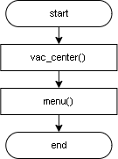
vac_center flow chart:
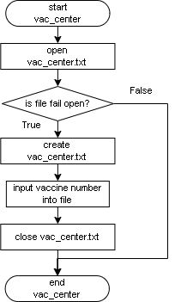
Main menu flow chart:
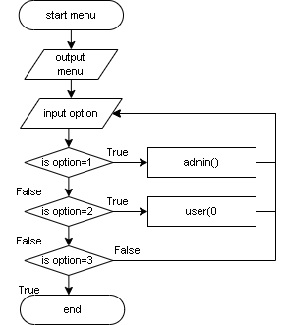
Admin Sign In flow chart:
T
F
Admin Sign In
a_name = “admin”
a_password = “admin”
START
Wrong name or password
Welcome admin
1. Admin
Admin Menu

Admin Menu flow chart:
True
a_option:
a_option: 1
START
add_vaccine_stock()
T
a_option: 2
display_vaccine_stock()
T
a_option: 3
view_vaccination()
T
a_option: 4
vaccination_record()
T
a_option: 5
apply_vaccine()
T
a_option: 6
delete_vaccination()
T
a_option: 7
menu();
Admin Menu
False
F
F
F
F
F
F
F

User flow chart:
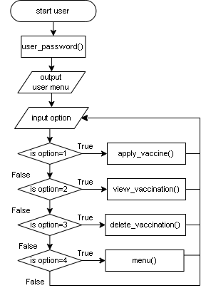

add_vaccine_stock flow chart:
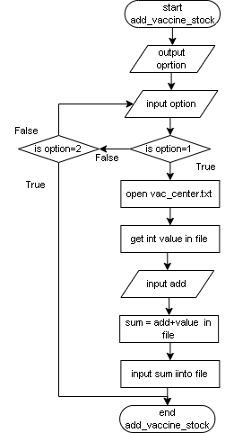

display_vaccine_stock flow chart:
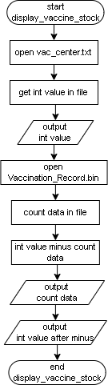

vaccination_record flow chart:
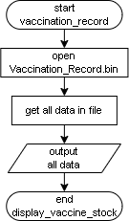

apply_vaccine flow chart:
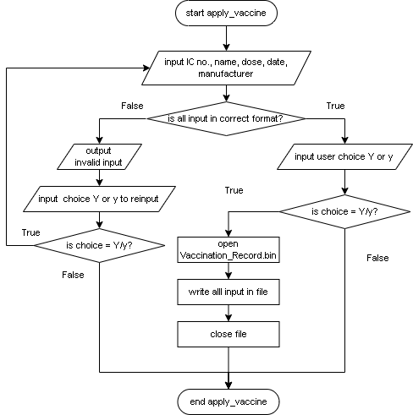

view_vaccination flow chart:
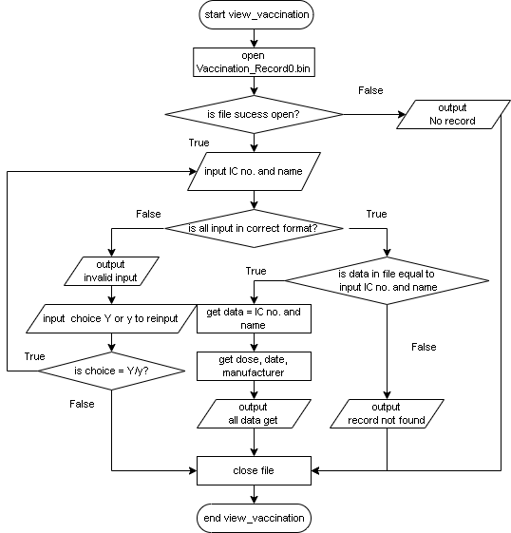
del_vaccination flow chart:
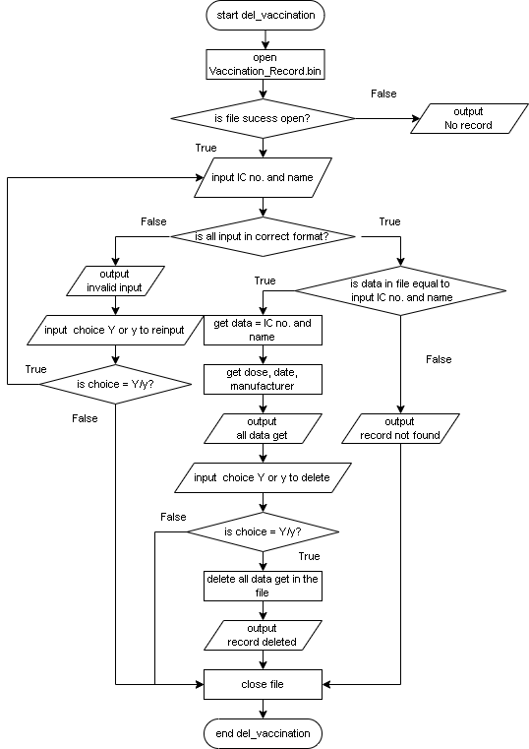

- A draft interface design

Main Menu
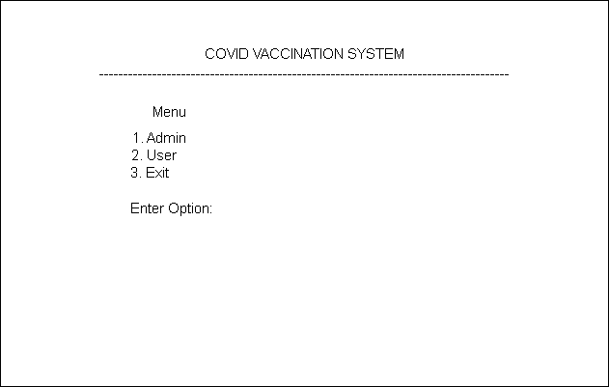

User Sub-Menu
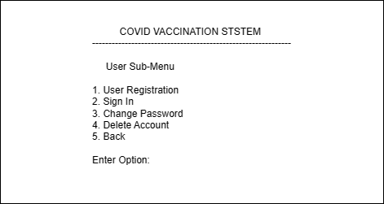

User Registration
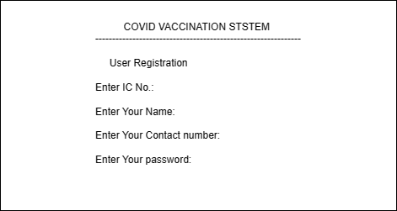

Sign In User
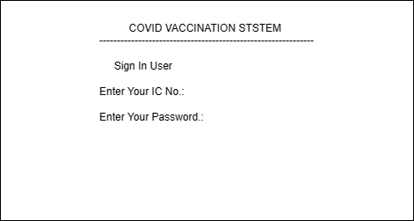

Change Password (User)
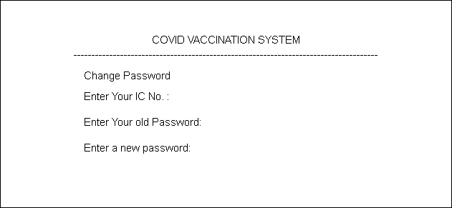

Delete Account (User)
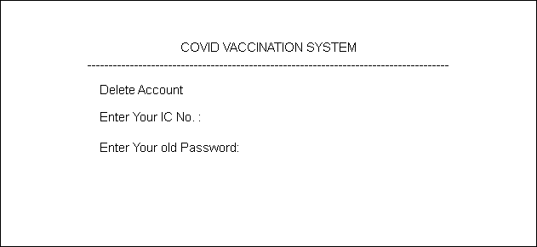

Apply Vaccine (User)
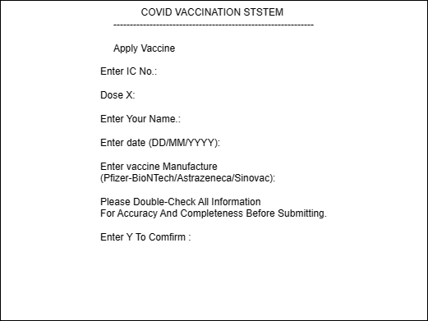

Check Vaccination Record (User)
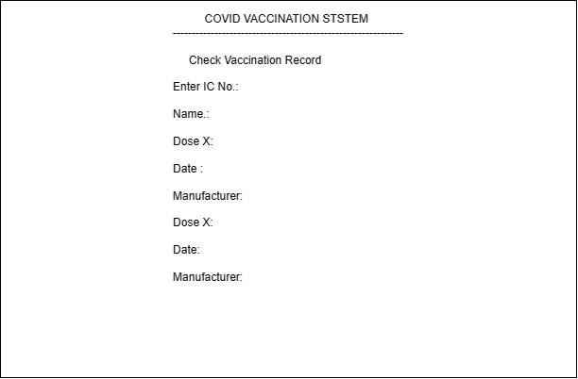

Delete Vaccination Record (Admin)
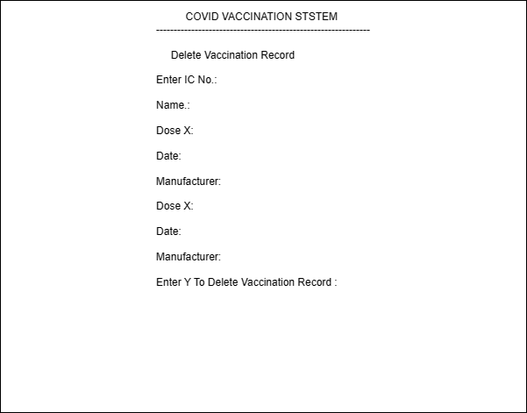

Sign In Admin
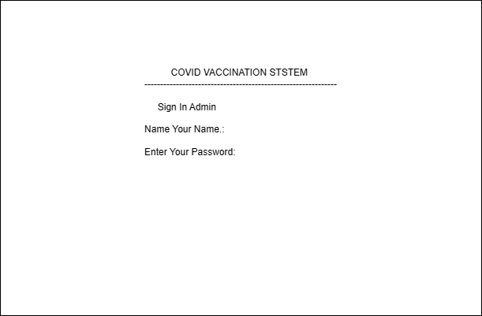

Show All Vaccination Record (Admin)


Show Vaccine Stock (Admin)
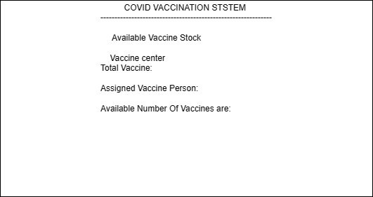

Add Vaccine Stock (Admin)
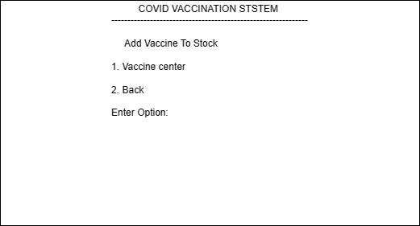
Add Vaccine Stock (Admin) when typed “2”
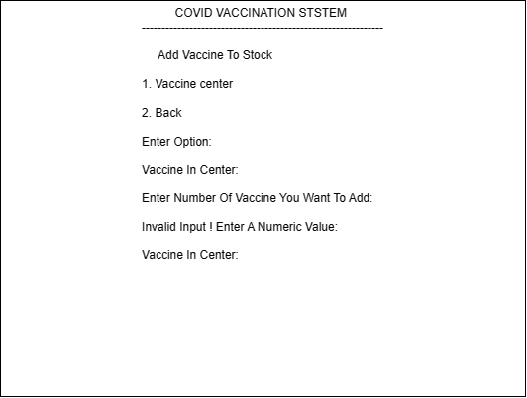

Screenshot of the program
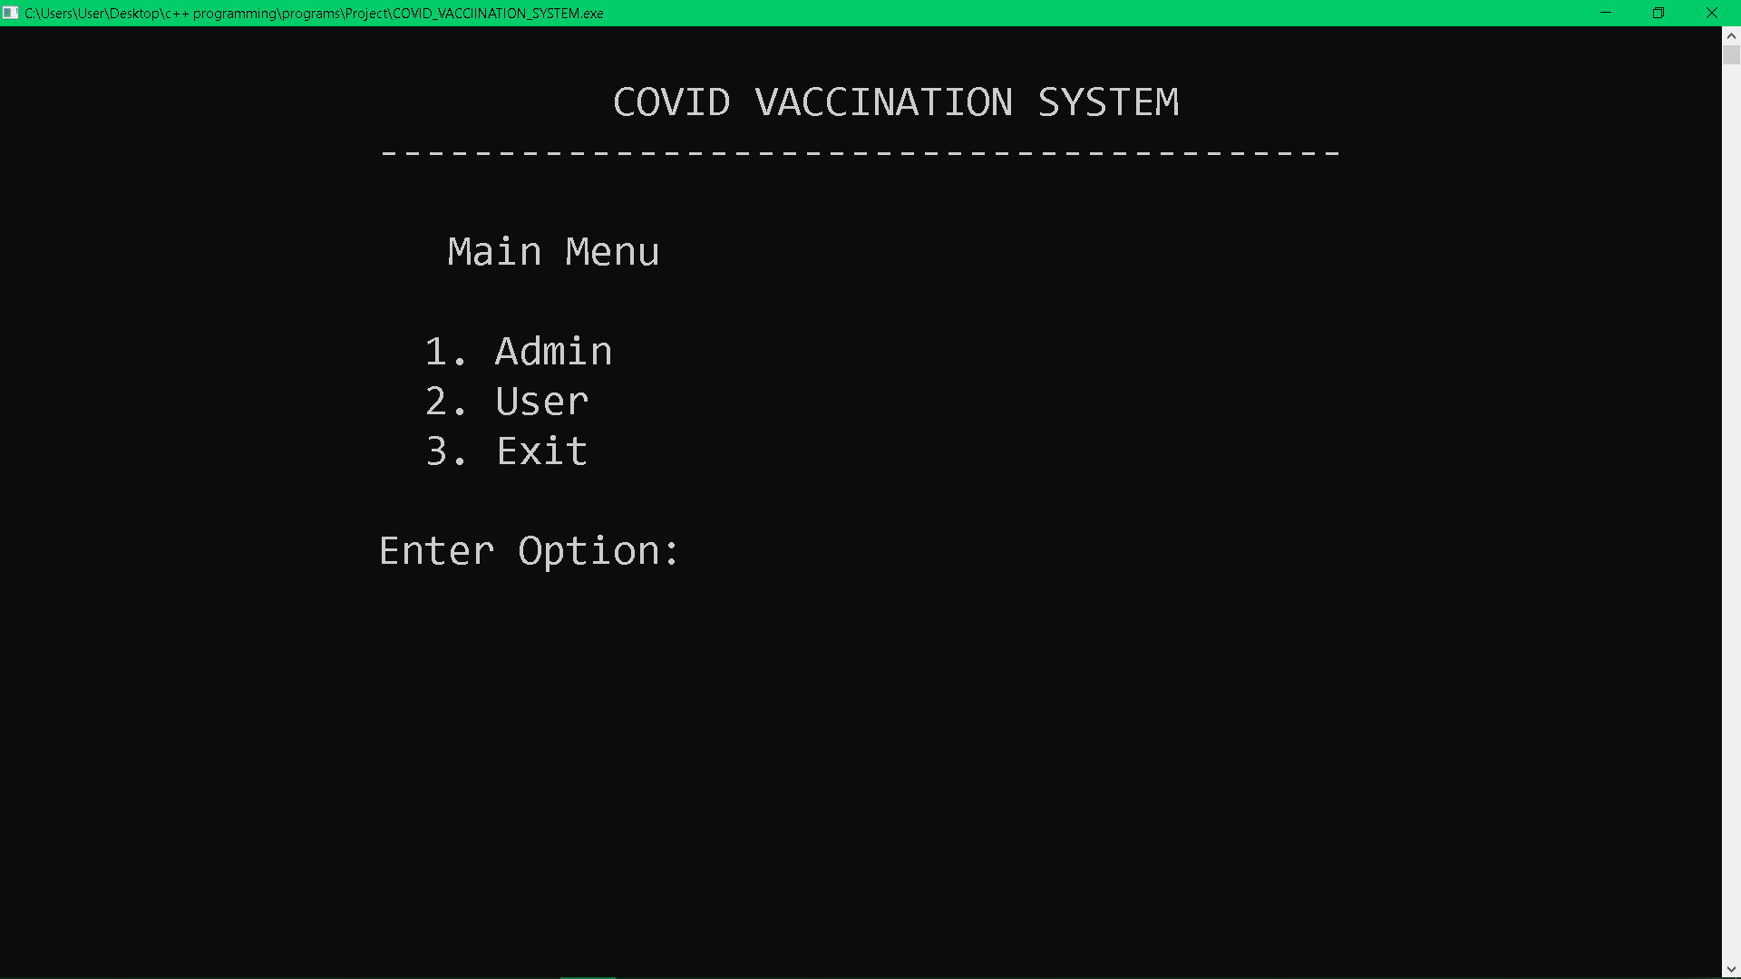This is the Main Menu, enter option 1, 2 or 3 to the features.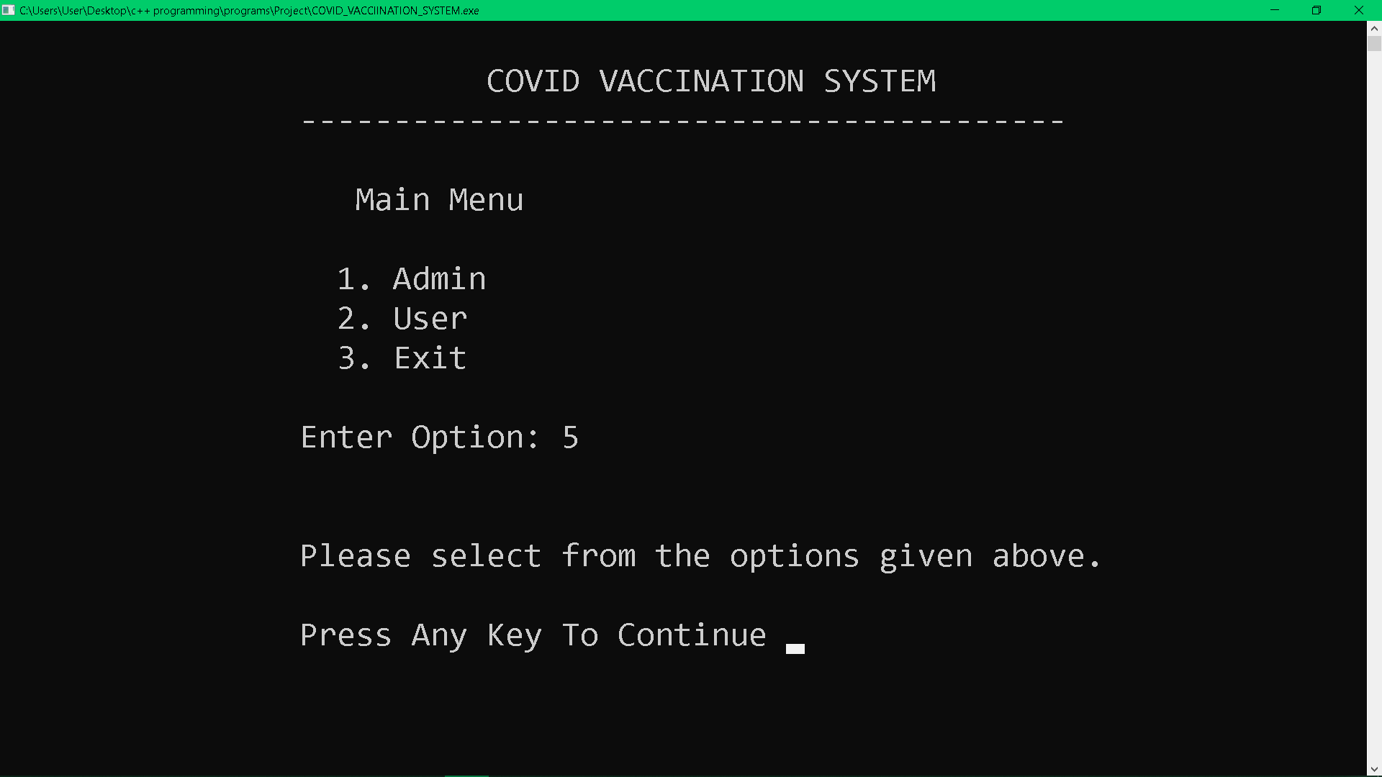If enter option not equal 1, 2 or 3. User have to reenter.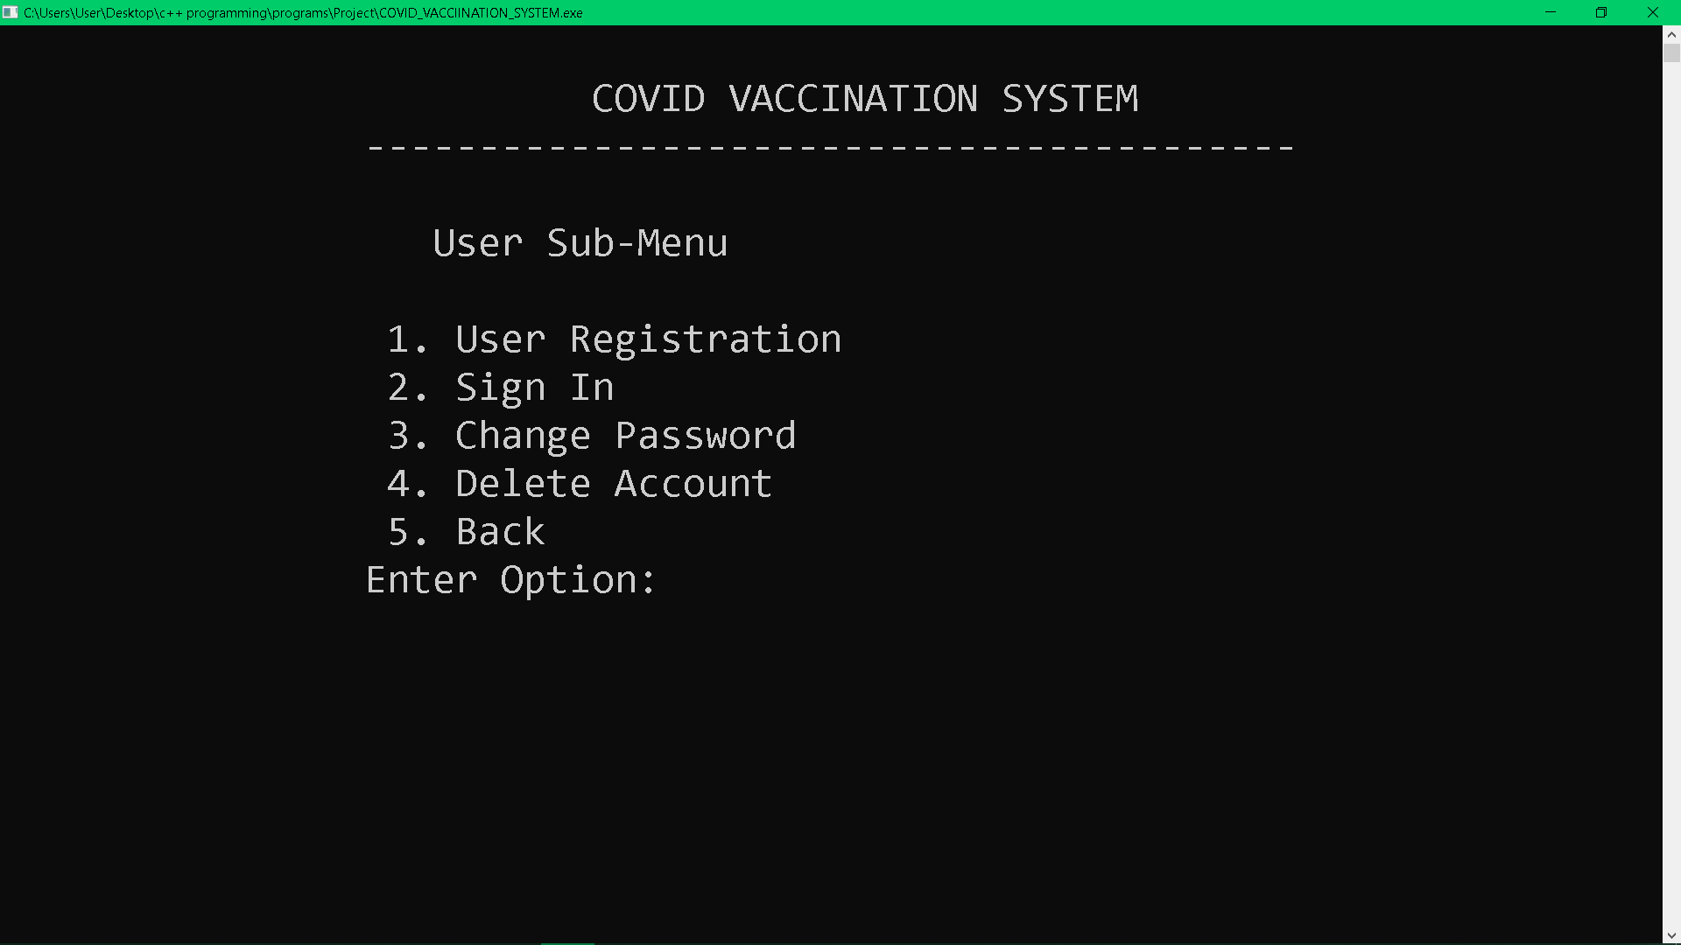This is User Sub-Menu, enter option 1 to 5 to the function.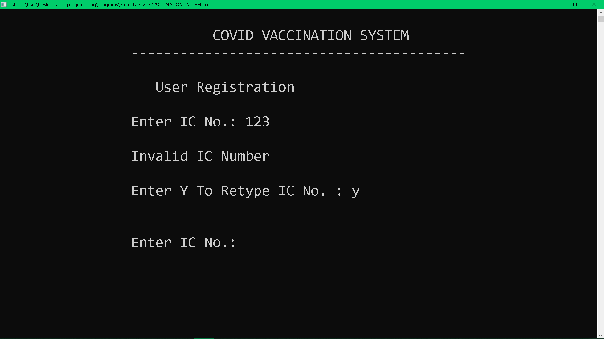If the IC no. lengths not equal to 12, it is not allowed and it will ask whether to retype or exit the User Registration. This parameter applies to all Enter IC no.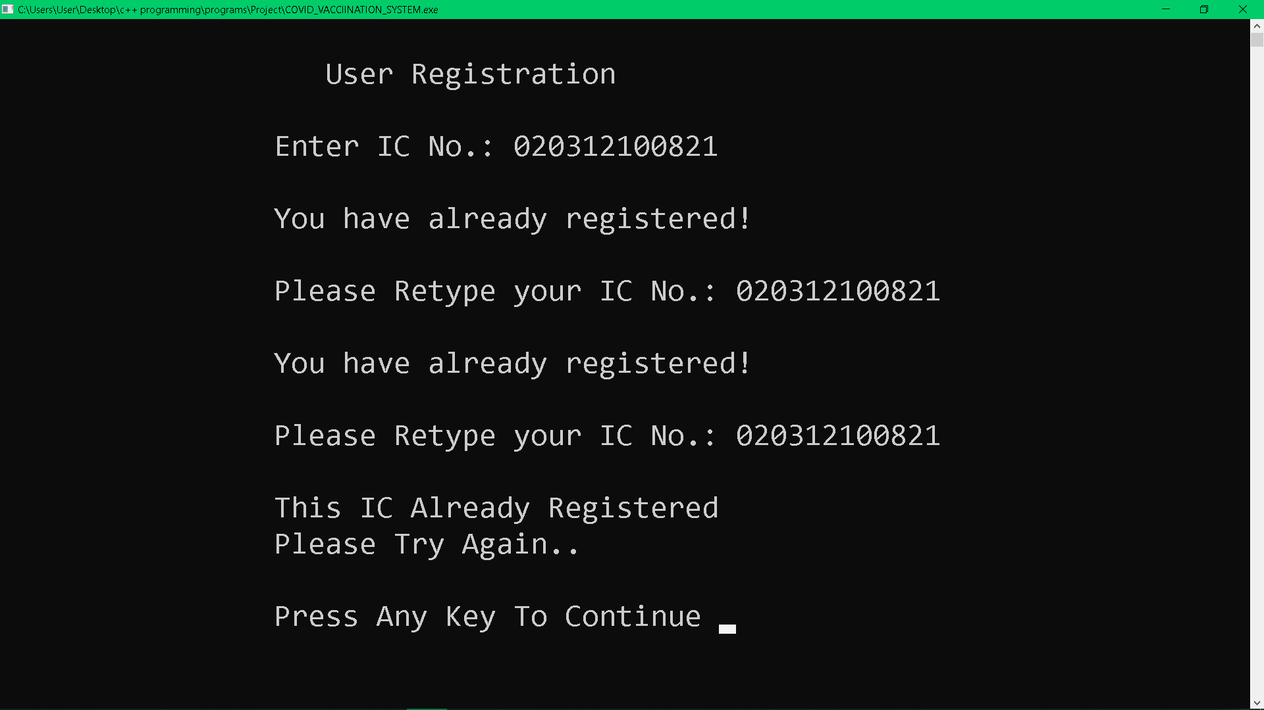

If the IC no. has been registered before. It is not allowed and it will ask to retype the IC number.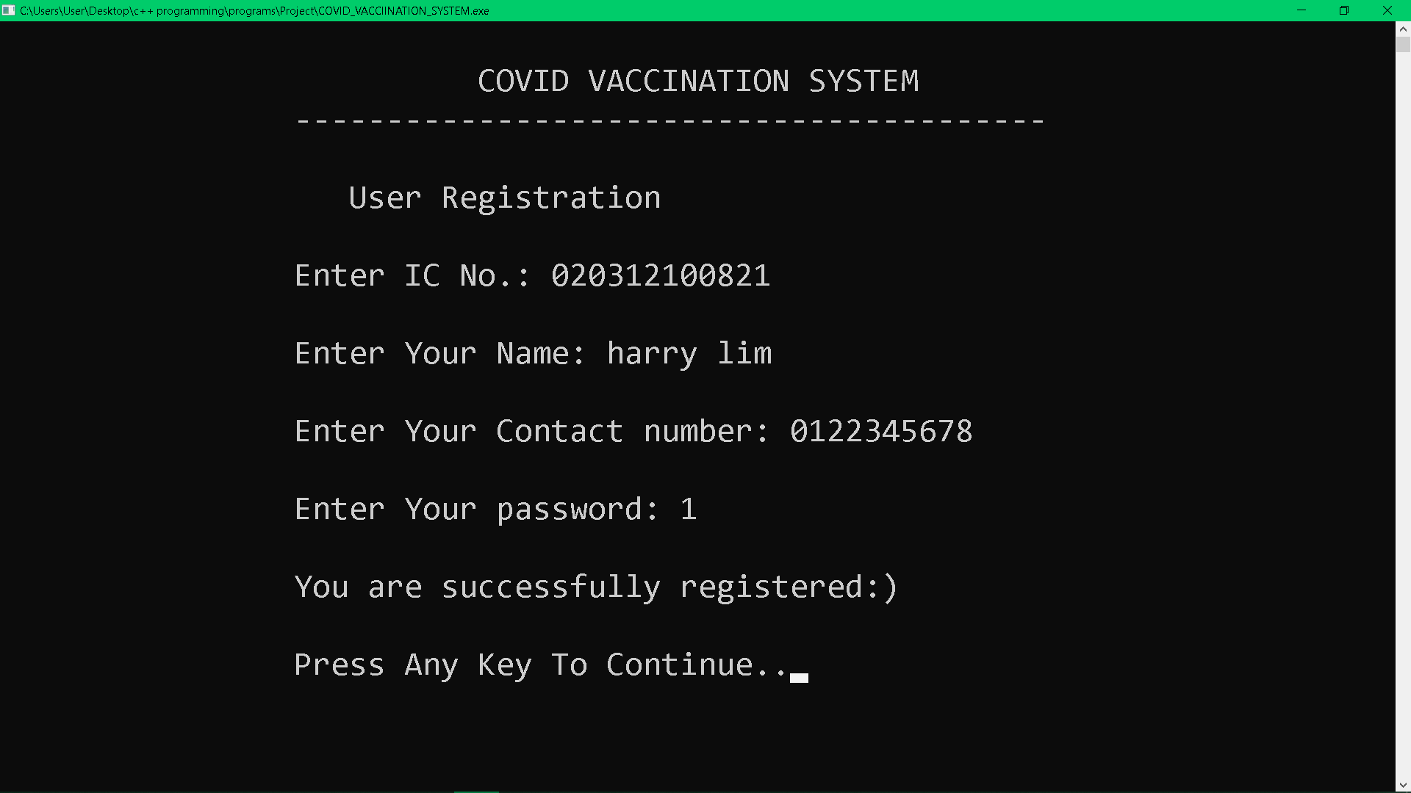If user enters all information to the requirement, User is successfully registered.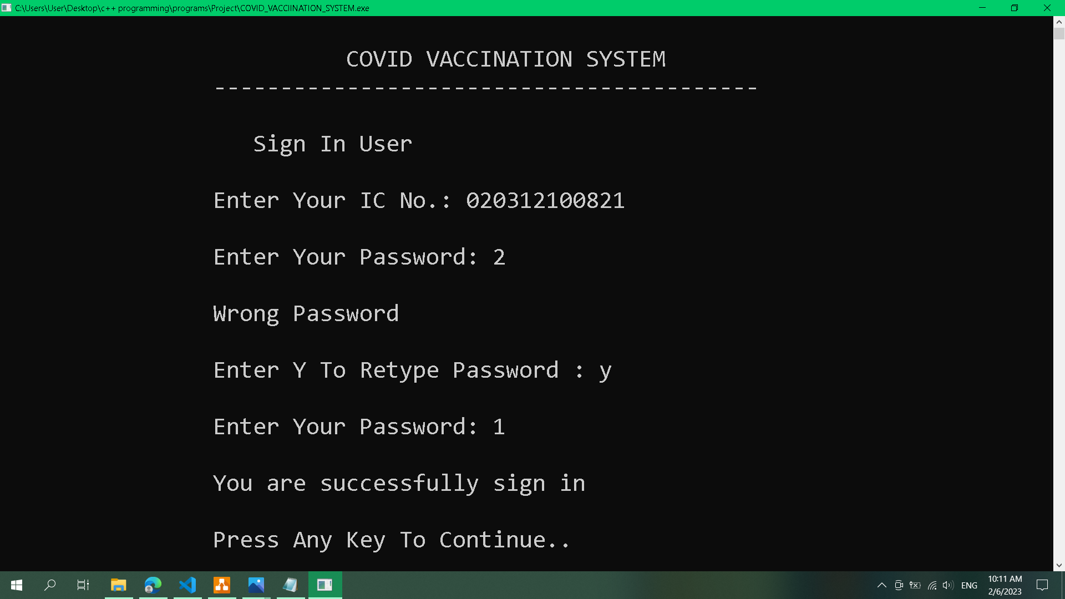

In the Sign In User, the user is required to enter their IC no. and the corresponding password to log in. 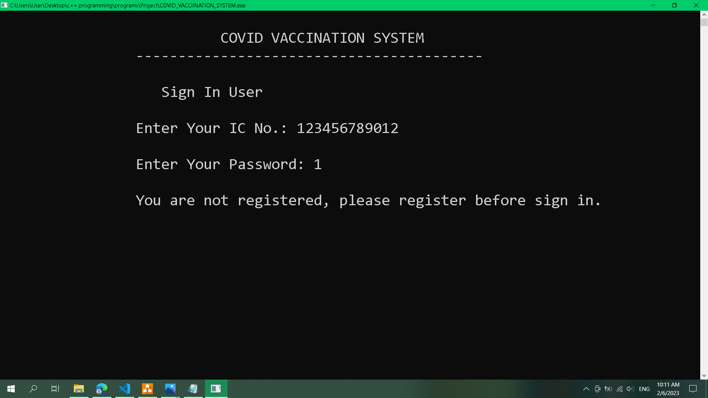If the enter IC no. is not registered before, it will ask the user to register first.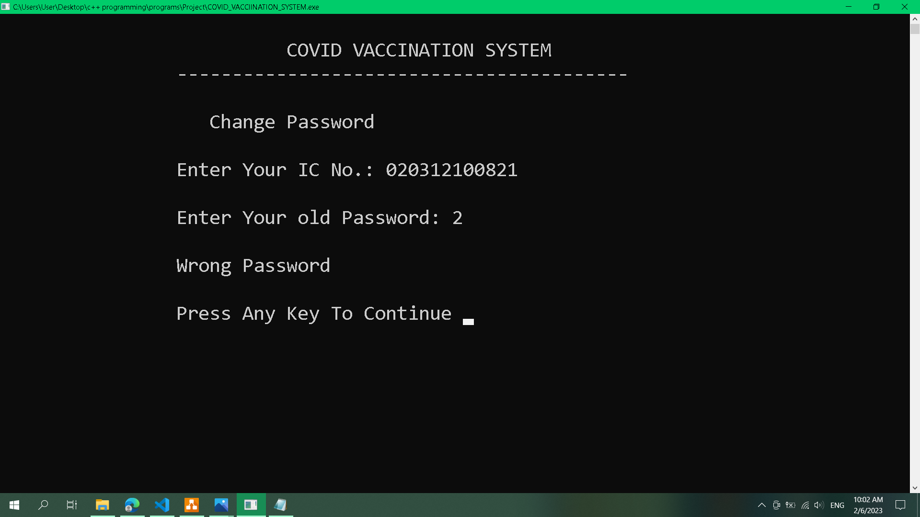If a user wants to change their password, the user is required to enter their IC no. and corresponding password before changing their password. Same goes to Delete Account.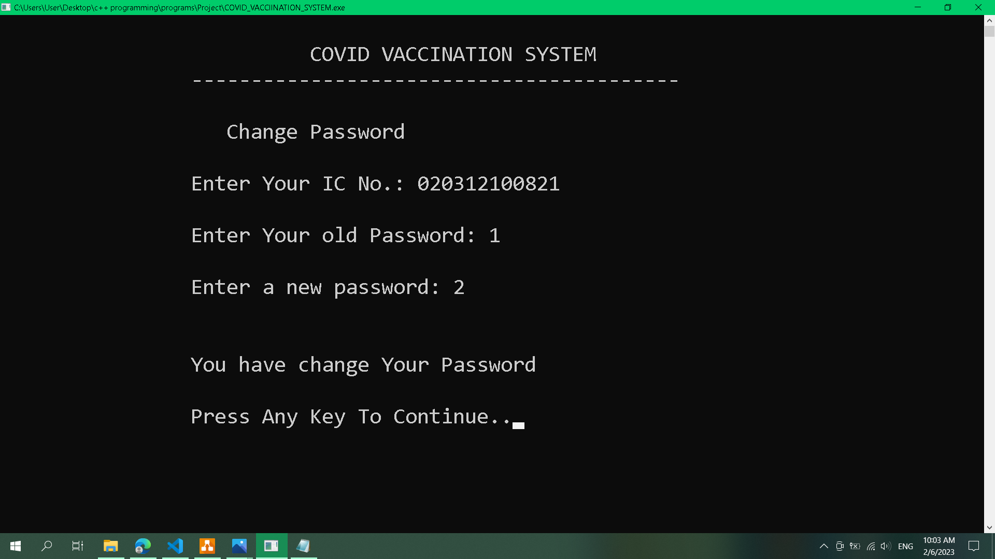
This is when user success changes their password.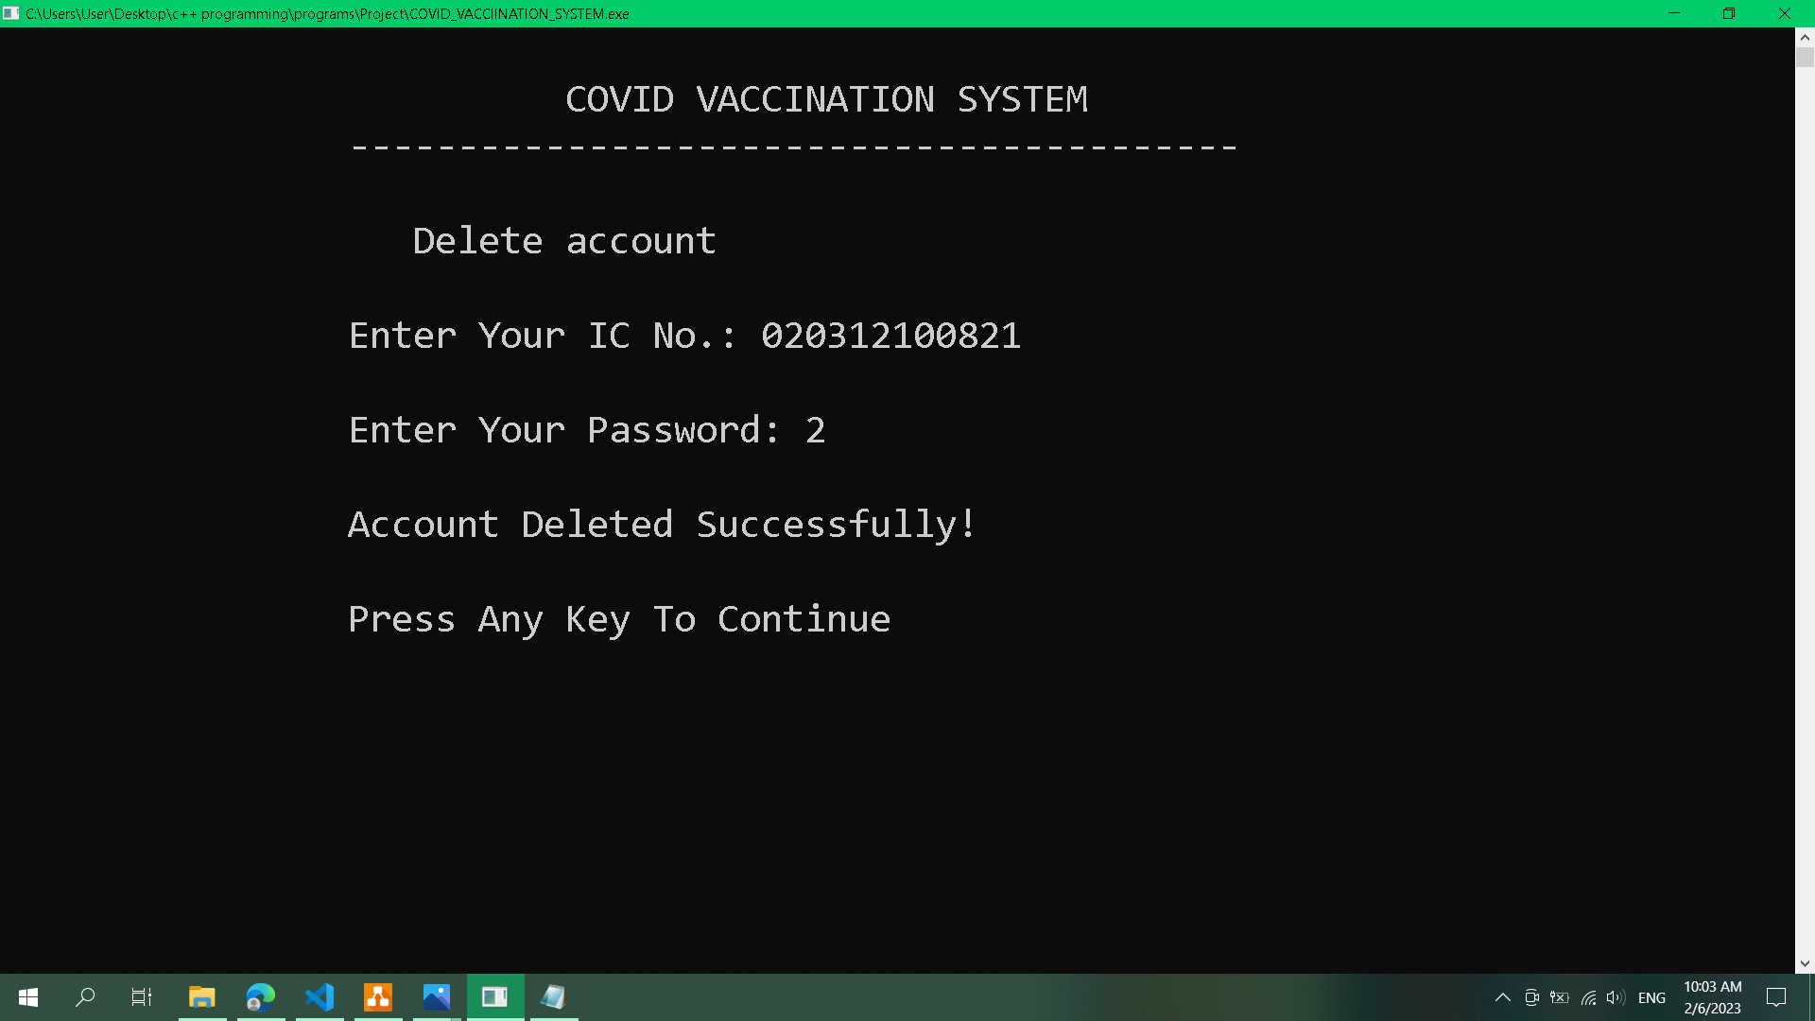This is when user success deletes thor account.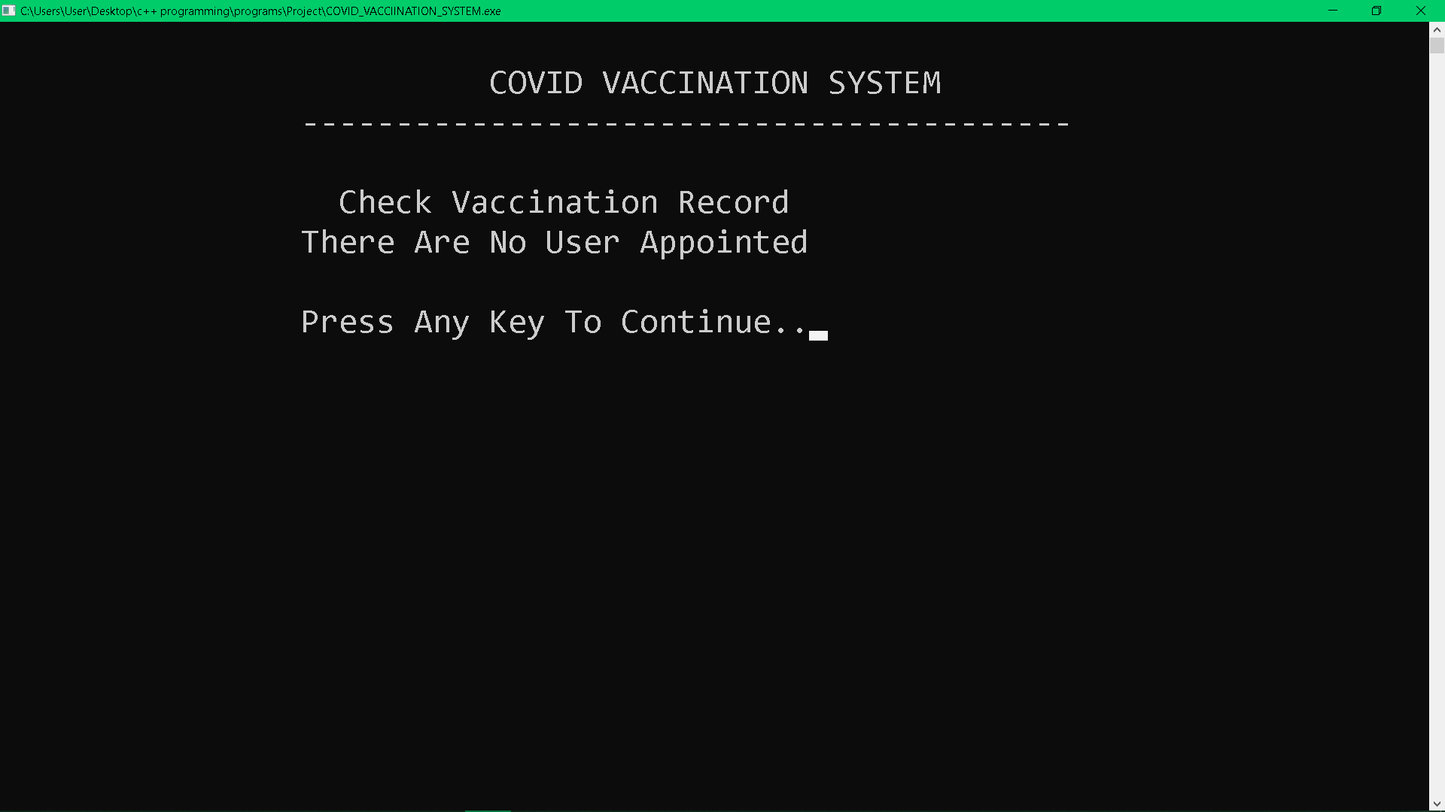In the Check Vaccination Record, if there is no user applied for the vaccine before, it will show "There Are No User Appointer”, same with Delete Vaccination Record.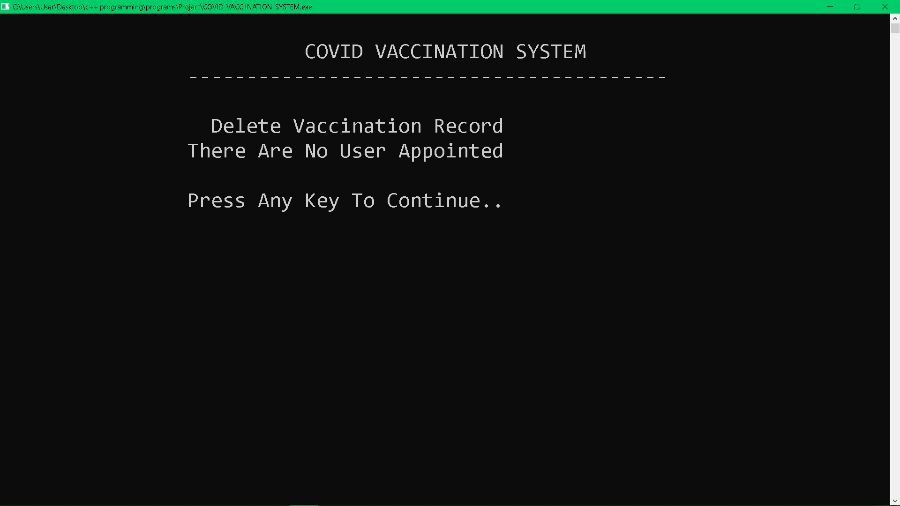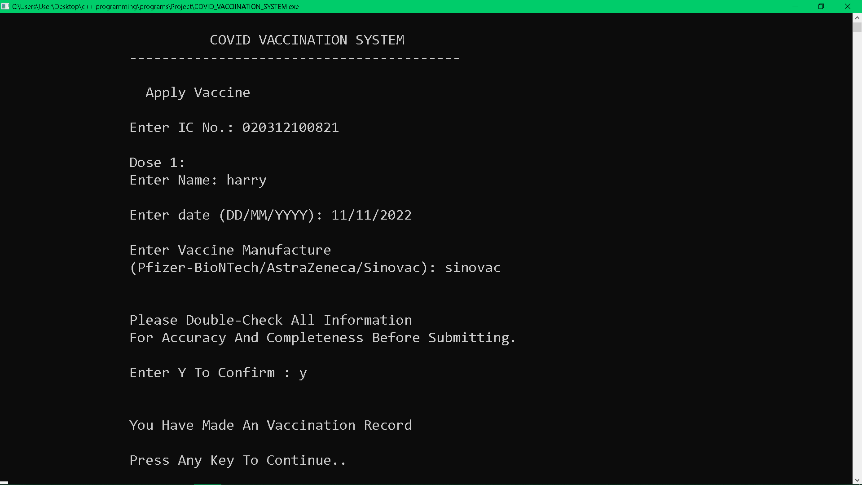In the Apply Vaccine, user is require to enter all the information accordingly and it will ask for a confirmation before record added.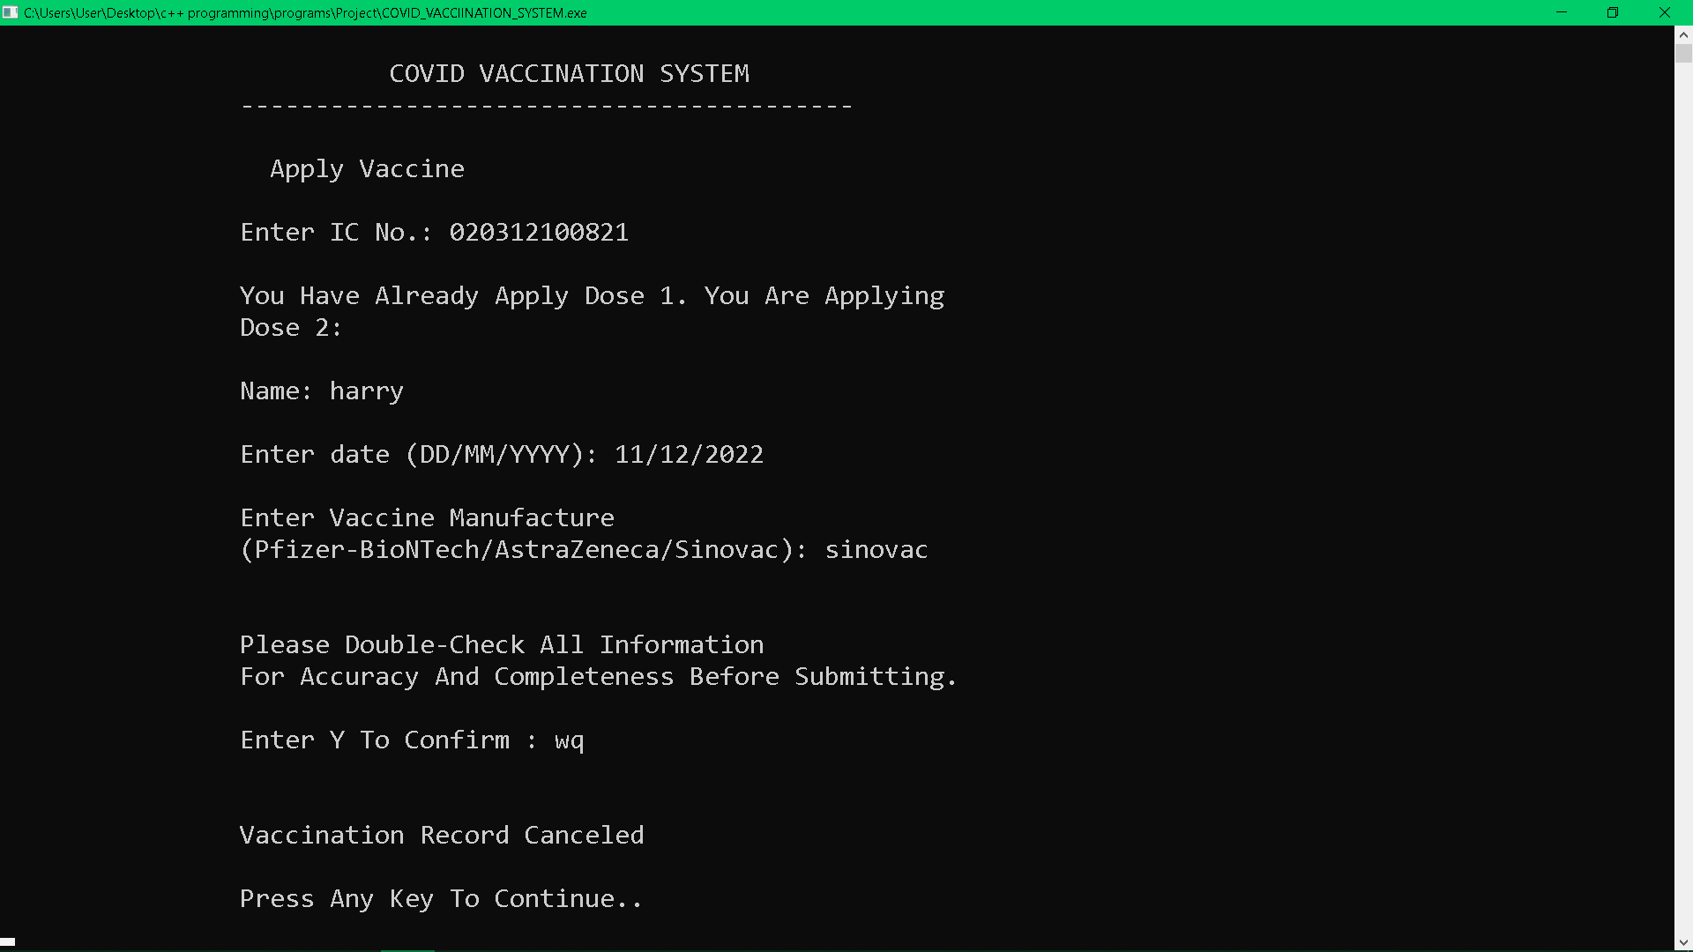If the uIC no. has already made the record before, It will notice the user is applying the next dose and show the corresponding name.
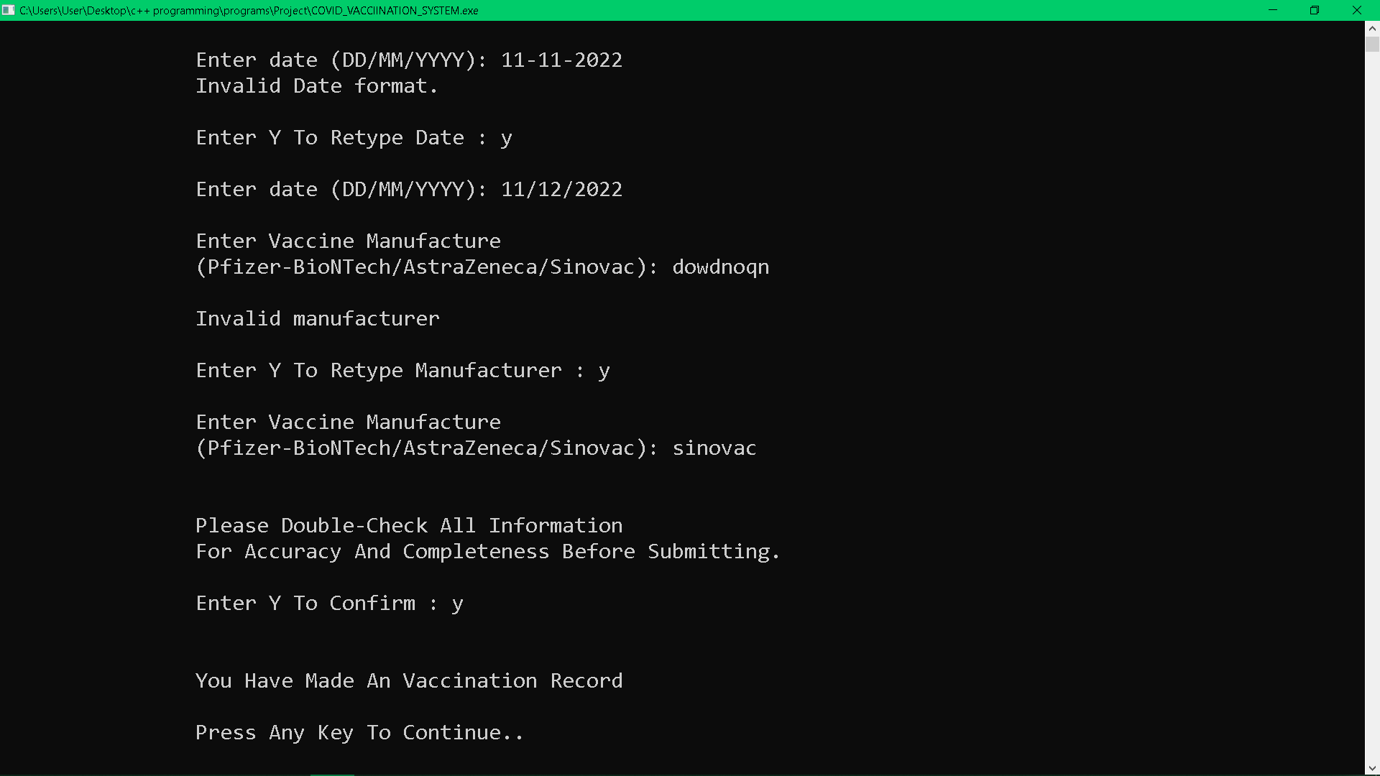If the user enters the wrong date format and manufacture, it will ask the user whether to retype or exit Apply Vaccine. 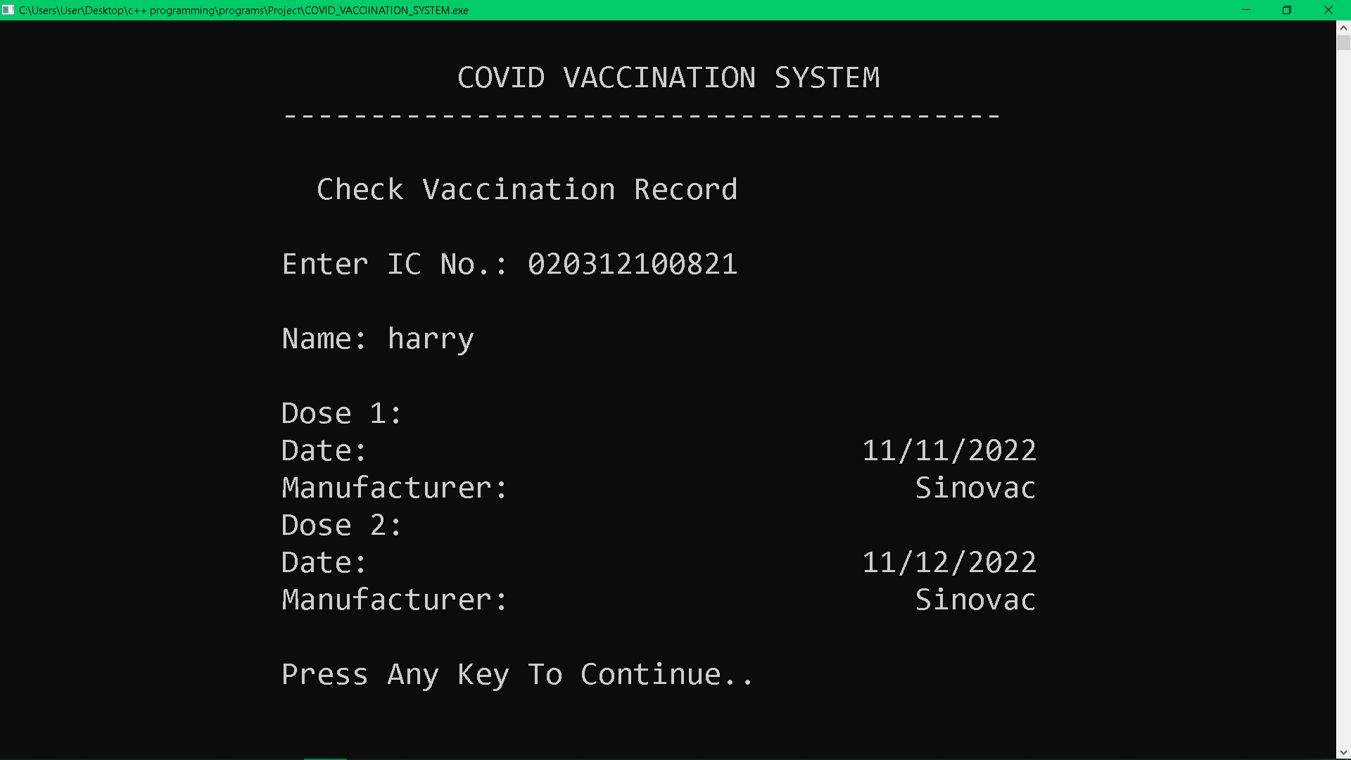In Check Vaccination Record, the user is required to enter the IC no. and corresponding name apply for vaccine in order to view the record. Same goes for the Delete Vaccination Record.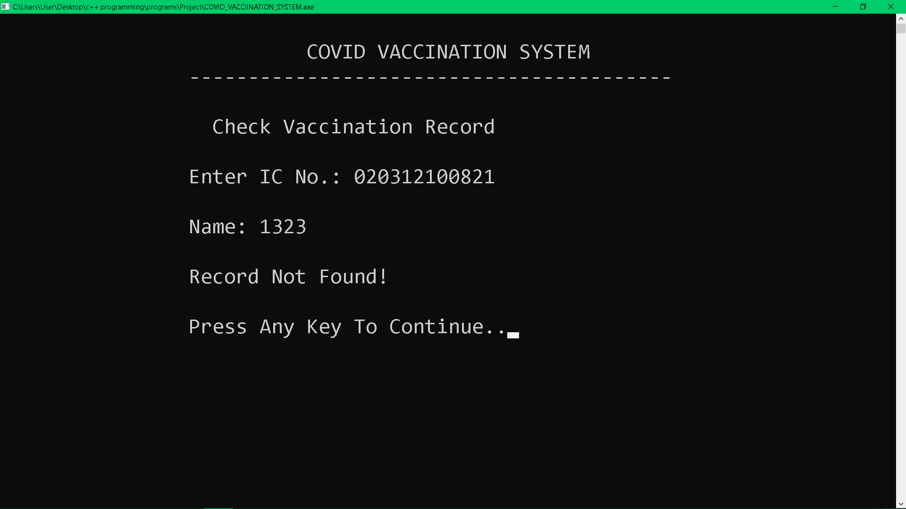If the user enters a registered IC no. but the name is not correct, the record will not be shown. Same goes for the Delete Vaccination Record.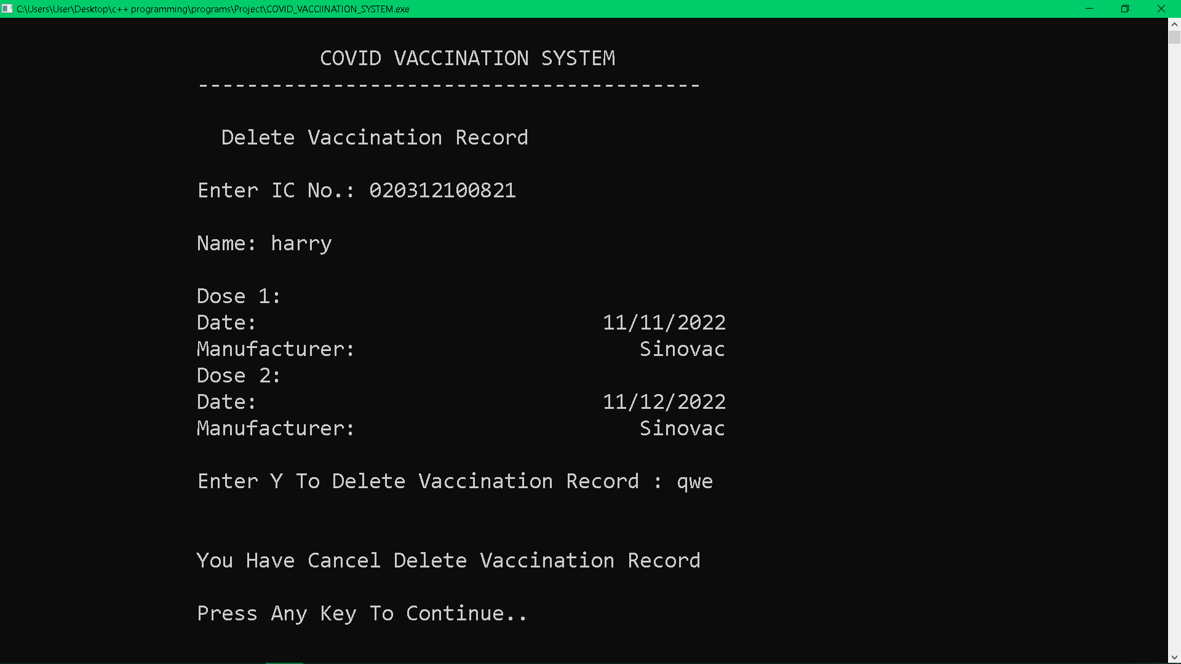In Delete Vaccination Record after the record is shown, it will ask for a confirmation whether to delete the record.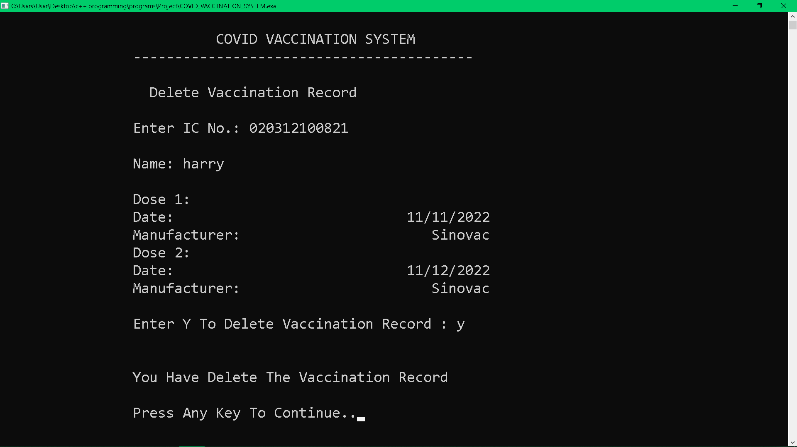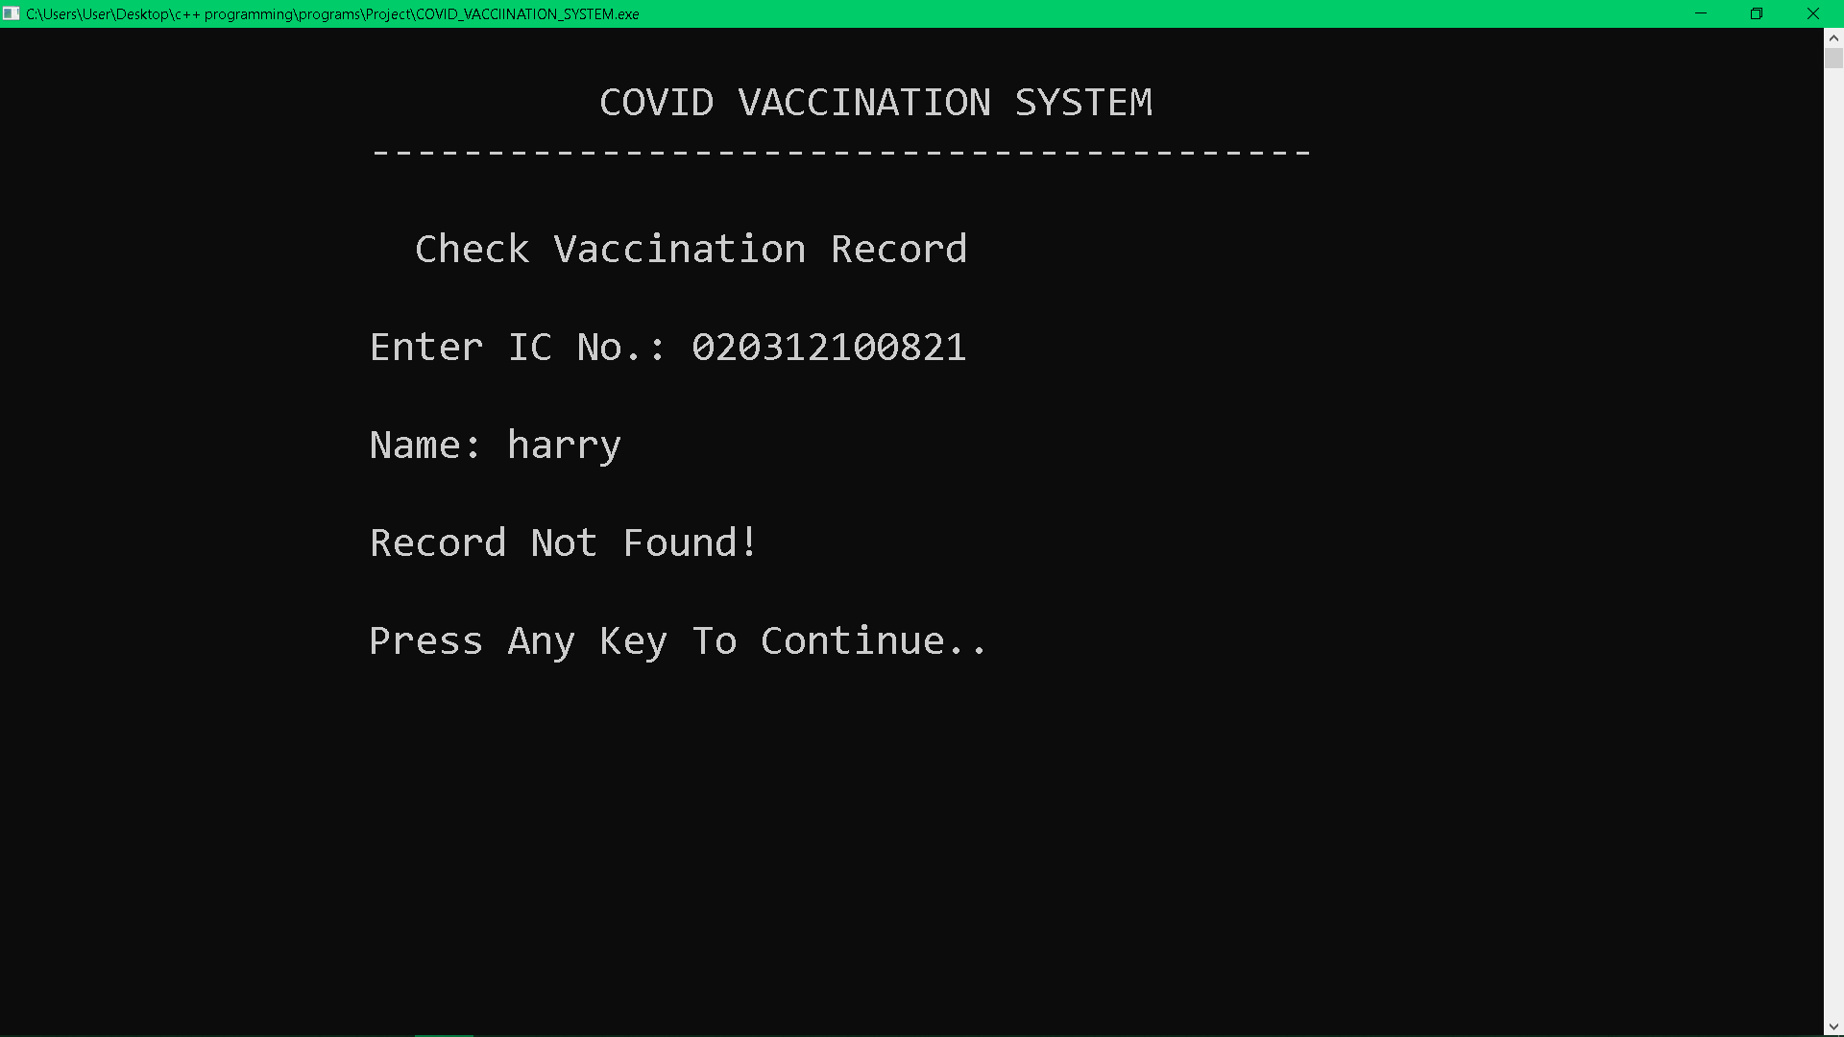If the user deletes the record. The user is unable to check their record again because it is already deleted.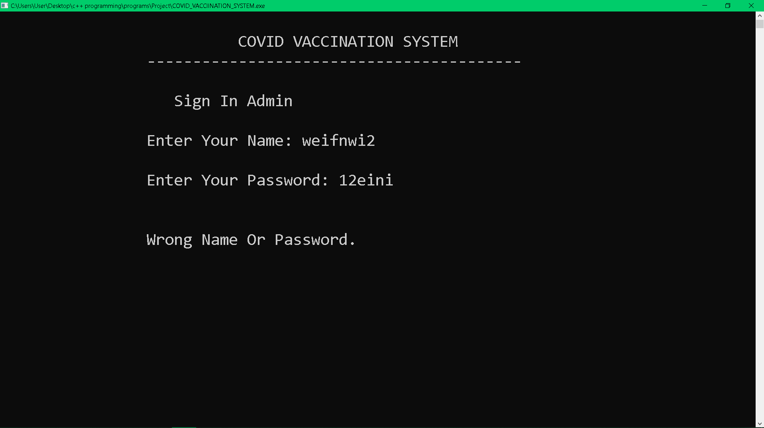In the Sign In admin, admin is required to “admin” for the name and admin for the password. Else, it will not sign in to Admin Menu.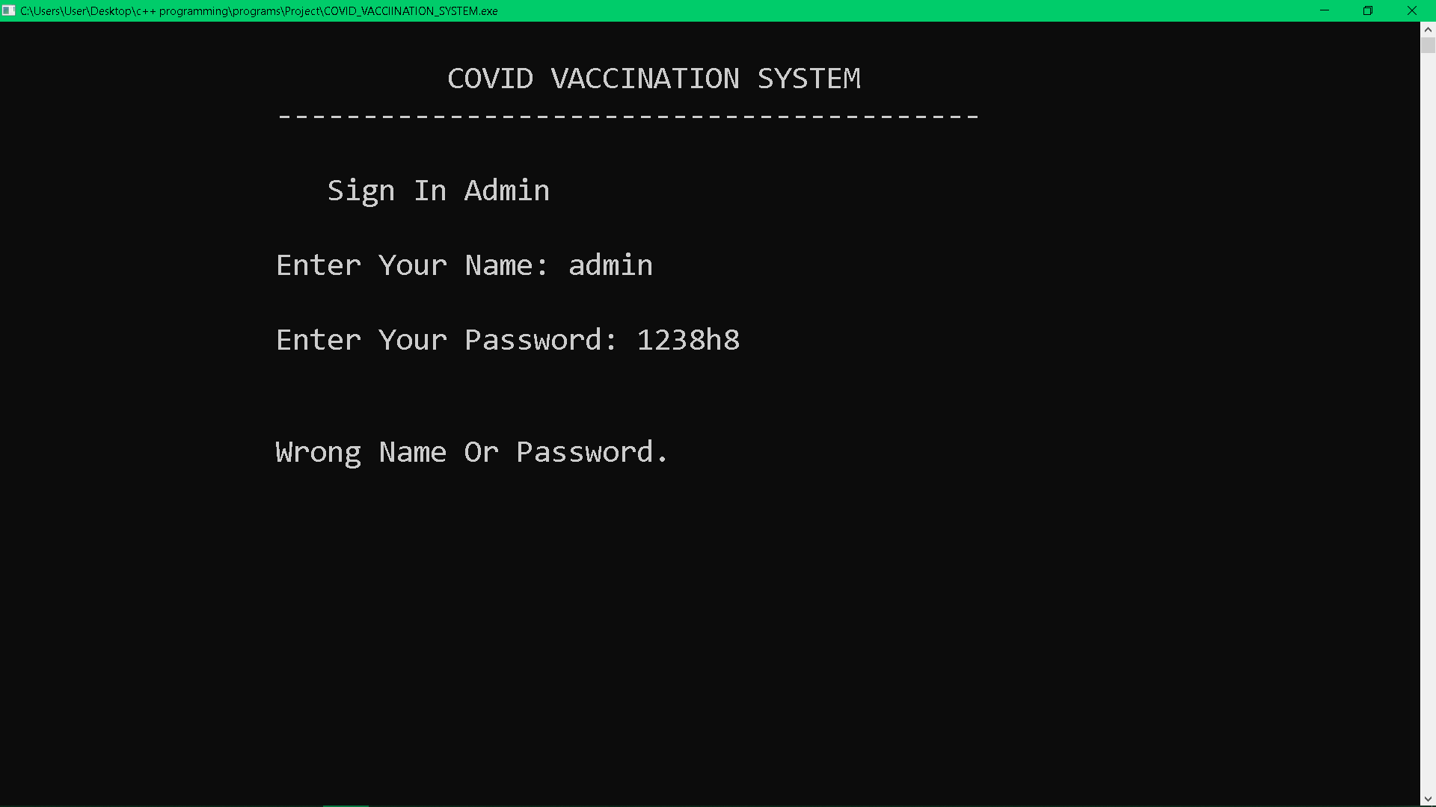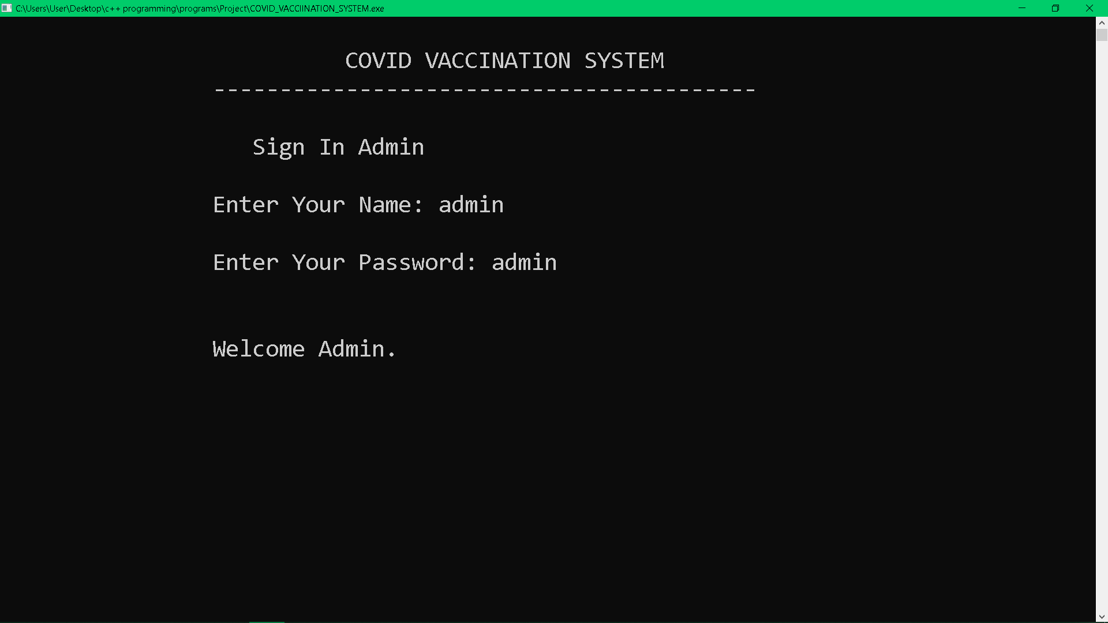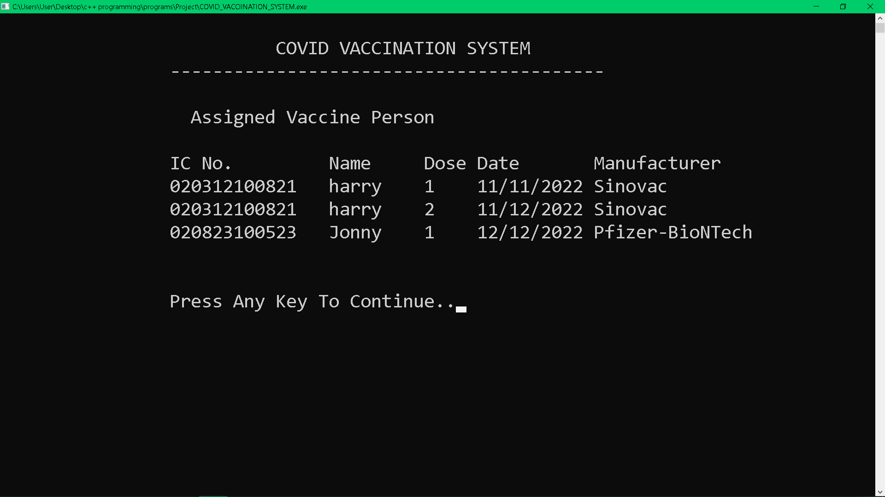In Assigned Vaccine Person, all IC no. apply for vaccine will be shown.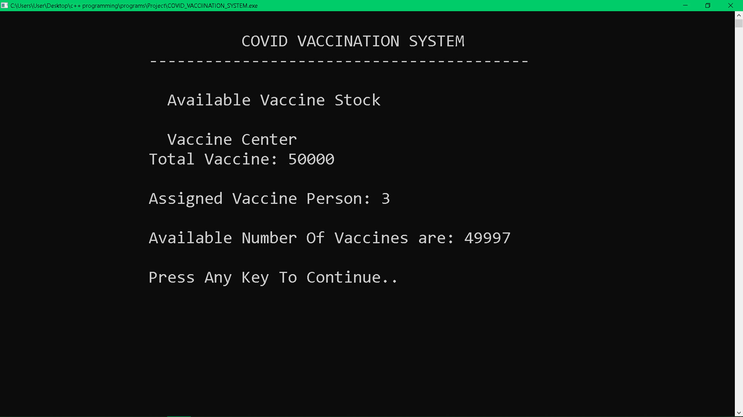In Available Stock, the vaccine in center is shown and it will minus the assigned vaccine person for the available vaccine number.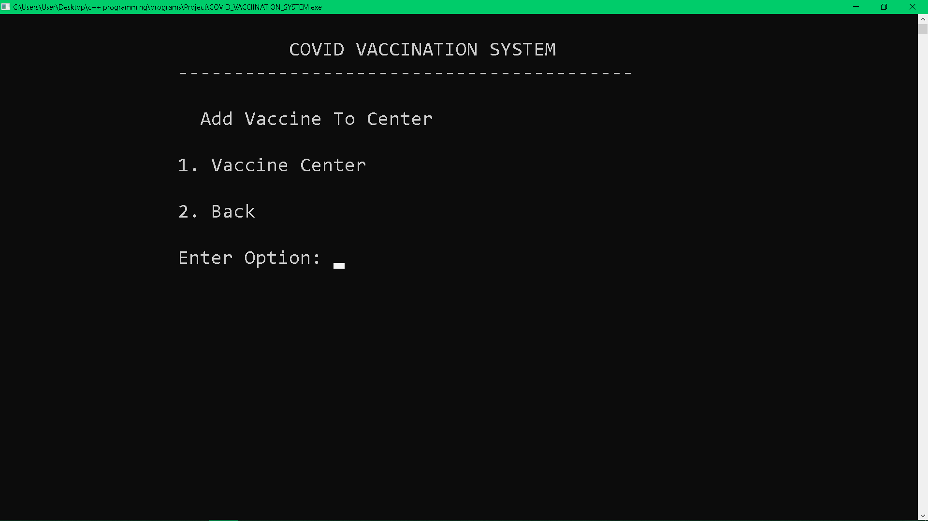In Add Vaccine to Center, admin enter 1 to add vaccine, 2 to back to admin menu. If user enter 1, vaccine in center is shown and user is required to enter number only.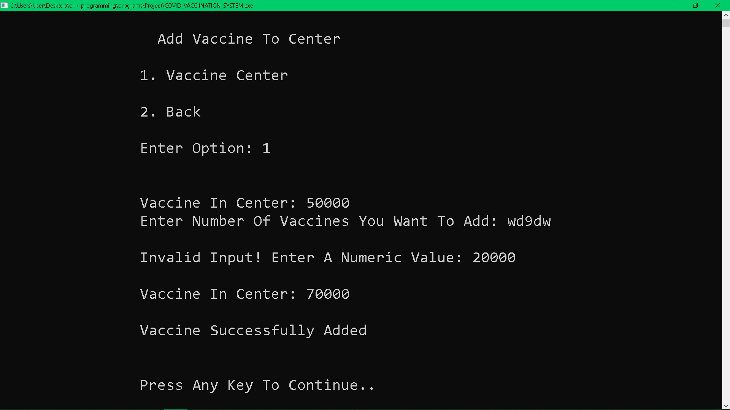
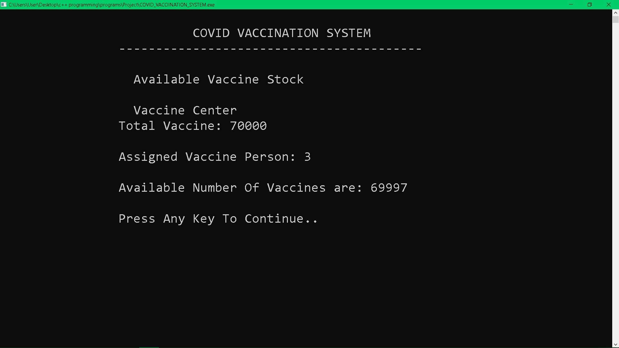
This is to show the vaccine is successfully added to the system.

Reference
- Ulla Kirch-Prinz and Peter Prinz, (2002) A Complete Guide to Programming in C++. Jones and Bartlett Publishers. Retrieved from http://www.lmpt.univ-tours.fr/~volkov/C++.pdf
- StudiesToday. CBSE Class 12 Computer Science - Data File Handling In C++. StudiesToday.com. Retrieved from https://www.studiestoday.com/concept-computer-science-cbse-class-12-computer-science-data-file-handling-c-220068.html

Appendix
#include <iostream>
#include <cstring> // strcpy compare string
#include <windows.h> // functions in the Windows API
#include <fstream> // create files, write information to files, and read information from files.
#include <conio.h> // getch
#include <iomanip> // setfill, setw
#include <string>
#include <cstdlib>
#include <limits>

using namespace std;

class covid_vaccination
{
protected:
string name;
string password;
string contact;
string user_name, user_IC;
string IC;

// vac center
string VacCenter = "Vaccine Center";

// vaccination data
struct vac_data
{
char uIC[13];
char uname[100];
char dose;
char manufacturer[16];
char udate[11];
};
int counter;

public:
void vac_center();

void title();
void retypeOpt(); // retype option

void menu();

// admin
void admin();
void admin_password();

// user
void user();
void user_password();
void valid(string str); // check IC exist

// admin func
void add_vaccine_stock();
void display_vaccine_stock();
void vaccination_record();

// both func
void apply_vaccine();
void view_vaccination();
void delete_vaccination();
};

void covid_vaccination::vac_center()
{
fstream file;

file.open("vac_center.txt", ios::in);
if (file.fail())
{
file.close();
file.open("vac_center.txt", ios::out | ios::app);
file << 50000;
}
file.close();
}

void covid_vaccination::title()
{
cout << "\n\t\t COVID VACCINATION SYSTEM ";
cout << "\n\t\t-----------------------------------------";
}

void covid_vaccination::retypeOpt()
{
cout << "\n\n\t\tPlease select from the options given above.";
cout << "\n\n\t\tPress Any Key To Continue ";
getch();
cin.clear();
fflush(stdin); // clear cin buffer
cout.flush(); // clear cout buffer
}

void covid_vaccination::menu()
{
system("cls"); // clear screen
int option;
title();
// main menu
cout << "\n\n\t\t Main Menu ";
cout << "\n\n\t\t 1. Admin";
cout << "\n\t\t 2. User";
cout << "\n\t\t 3. Exit";
cout << "\n\n\t\tEnter Option: ";
cin >> option;
// call function by chosen num
switch (option)
{
case 1:
admin();
break;
case 2:
user();
break;
case 3:
system("cls");
cout << "\n\n\t\t\t COVID VACCINATION SYSTEM";
Sleep(10);
exit(0);
default:
retypeOpt();
menu();
}
}

// admin
void covid_vaccination::admin()
{
admin_password();
A:
system("cls");
int a_option;
title();
cout << "\n\n\t\t Admin Menu ";
cout << "\n\n\t\t 1. Add Vaccine Stock";
cout << "\n\t\t 2. Show Vaccine Stock";
cout << "\n\t\t 3. Search Vaccination Record";
cout << "\n\t\t 4. Show All Vaccination Record";
cout << "\n\t\t 5. Add Vaccination Record";
cout << "\n\t\t 6. Delete Vaccination Record";
cout << "\n\t\t 7. Sign Out";
cout << "\n\n\t\tEnter Option: ";
cin >> a_option;
switch (a_option)
{
case 1:
add_vaccine_stock();
goto A;
break;
case 2:
display_vaccine_stock();
goto A;
break;
case 3:
view_vaccination();
goto A;
break;
case 4:
vaccination_record();
goto A;
break;
case 5:
apply_vaccine();
goto A;
break;
case 6:
delete_vaccination();
goto A;
break;
case 7:
menu();
default:
retypeOpt();
goto A;
break;
}
}

void covid_vaccination::admin_password()
{
system("cls");
char a_name[20];
char a_password[20];
title();
cout << "\n\n\t\t Sign In Admin ";
cout << "\n\n\t\tEnter Your Name: ";
cin >> a_name;
cout << "\n\t\tEnter Your Password: ";
cin >> a_password;
if ((strcmp(a_name, "admin") == 0) && (strcmp(a_password, "admin") == 0))
{
cout << "\n\n\t\tWelcome Admin.\n\n";
getch();
system("cls");
}
else
{
cout << "\n\n\t\tWrong Name Or Password.\n\n";
getch();
system("cls");
menu();
}
}

// user
void covid_vaccination::user()
{
user_password();
B:
system("cls");
int u_option;
title();
cout << "\n\n\t\t User Menu ";
cout << "\n\t\t Welcome " << user_name;
cout << "\n\t\t 1. Apply For Vaccine";
cout << "\n\t\t 2. View Vaccination Record";
cout << "\n\t\t 3. Delete Vaccination Record";
cout << "\n\t\t 4. Sign Out";
cout << "\n\n\t\tEnter Option: ";
cin >> u_option;
switch (u_option)
{
case 1:
apply_vaccine();
goto B;
case 2:
view_vaccination();
goto B;
case 3:
delete_vaccination();
goto B;
case 4:
menu();
default:
retypeOpt();
goto B;
}
}

void covid_vaccination::user_password()
{
system("cls");
int u_option;
string fname, usern, userp;
ofstream fileo;
ifstream filei;
title();
cout << "\n\n\t\t User Sub-Menu ";
cout << "\n\n\t\t 1. User Registration";
cout << "\n\t\t 2. Sign In";
cout << "\n\t\t 3. Change Password";
cout << "\n\t\t 4. Delete Account";
cout << "\n\t\t 5. Back";
cout << "\n\t\tEnter Option: ";
cin >> u_option;
if (u_option == 1)
{
system("cls");
title();
cout << "\n\n\t\t User Registration ";
A:
cout << "\n\n\t\tEnter IC No.: ";
cin >> IC;
if (IC.length() != 12)
{
cout << "\n\t\tInvalid IC Number";
char choice;
cout << "\n\n\t\tEnter Y To Retype IC No. : ";
cin >> choice;
if (choice == 'y' || choice == 'Y')
{
goto A;
}
else
{
cin.clear();
fflush(stdin); // clear input buffer
user();
}
}
counter = 0;
valid(IC);
if (counter >= 3)
{
cout << "\n\n\t\tPress Any Key To Continue ";
getch();
user_password();
}
cout << "\n\t\tEnter Your Name: ";
cin.ignore();
getline(cin, name);
cout << "\n\t\tEnter Your Contact number: ";
cin >> contact;
cout << "\n\t\tEnter Your password: ";
cin >> password;
fname = IC + ".txt";
fileo.open(fname.c_str());
fileo << name << endl
<< password << endl
<< contact << endl;
cout << "\n\t\tYou are successfully registered:)";
cout << "\n\n\t\tPress Any Key To Continue..";
Sleep(500);
getch();
fileo.close();
user();
}
else if (u_option == 2)
{
system("cls");
string u_IC, u_pass;
title();
cout << "\n\n\t\t Sign In User ";
B:
cout << "\n\n\t\tEnter Your IC No.: ";
cin >> u_IC;
if (u_IC.length() != 12)
{
cout << "\n\t\tInvalid IC Number";
char choice;
cout << "\n\n\t\tEnter Y To Retype IC No. : ";
cin >> choice;
if (choice == 'y' || choice == 'Y')
{
goto B;
}
else
{
cin.clear();
fflush(stdin); // clear input buffer
user();
}
}
C:
cout << "\n\t\tEnter Your Password: ";
cin >> u_pass;
fname = u_IC + ".txt";
filei.open(fname.c_str());
if (!filei.is_open() && filei.fail())
{
cout << "\n\t\tYou are not registered, please register before sign in.\n";
filei.close();
getch();
user_password();
}
getline(filei, usern);
getline(filei, userp);
if (u_pass == userp)
{
user_IC = u_IC;
user_name = usern;
cout << "\n\t\tYou are successfully sign in";
cout << "\n\n\t\tPress Any Key To Continue..";
getch();
}
else if (u_pass != userp)
{
cout << "\n\t\tWrong Password";
char choice2;
cout << "\n\n\t\tEnter Y To Retype Password : ";
cin >> choice2;
if (choice2 == 'y' || choice2 == 'Y')
{
goto C;
}
else
{
cout << "\n\n\t\tPress Any Key To Continue ";
getch();
cin.clear();
fflush(stdin);
cout.flush();
user_password();
}
}
}
else if (u_option == 3)
{
system("cls");
string u_IC, u_pass;
title();
cout << "\n\n\t\t Change Password ";
D:
cout << "\n\n\t\tEnter Your IC No.: ";
cin >> u_IC;
if (u_IC.length() != 12)
{
cout << "\n\t\tInvalid IC Number";
char choice;
cout << "\n\n\t\tEnter Y To Retype IC No. : ";
cin >> choice;
if (choice == 'y' || choice == 'Y')
{
goto D;
}
else
{
cin.clear();
fflush(stdin); // clear input buffer
user();
}
}
fname = u_IC + ".txt";
filei.open(fname.c_str());
if (!filei.is_open() && filei.fail())
{
cout << "\n\t\tYou are not registered, please register before changing password.\n";
filei.close();
getch();
user_password();
}
getline(filei, usern);
getline(filei, userp);
filei.close();
cout << "\n\t\tEnter Your old Password: ";
cin >> u_pass;
if (u_pass == userp)
{
string newPassword;
cout << "\n\t\tEnter a new password: ";
cin >> newPassword;
ofstream fileo;
fileo.open(fname.c_str());
fileo << usern << endl
<< newPassword;
fileo.close();
cout << "\n\n\t\tYou have change Your Password";
cout << "\n\n\t\tPress Any Key To Continue..";
getch();
system("cls");
cin.clear();
fflush(stdin);
cout.flush();
user_password();
}
else if (u_pass != userp)
{
cout << "\n\t\tWrong Password";
cout << "\n\n\t\tPress Any Key To Continue ";
getch();
cin.clear();
fflush(stdin);
cout.flush();
user_password();
}
}
else if (u_option == 4)
{
system("cls");
string u_IC, u_pass;
title();
cout << "\n\n\t\t Delete account ";
E:
cout << "\n\n\t\tEnter Your IC No.: ";
cin >> u_IC;
if (u_IC.length() != 12)
{
cout << "\n\t\tInvalid IC Number";
char choice;
cout << "\n\n\t\tEnter Y To Retype IC No. : ";
cin >> choice;
if (choice == 'y' || choice == 'Y')
{
goto E;
}
else
{
cin.clear();
fflush(stdin); // clear input buffer
user();
}
}
fname = u_IC + ".txt";
filei.open(fname.c_str());
if (!filei.is_open() && filei.fail())
{
cout << "\n\t\tAccount not exitst.\n";
filei.close();
getch();
user_password();
}
getline(filei, usern);
getline(filei, userp);
filei.close();
cout << "\n\t\tEnter Your Password: ";
cin >> u_pass;
if (u_pass == userp)
{
int result = remove(fname.c_str());
if (result == 0)
{
cout << "\n\t\tAccount Deleted Successfully!";
cout << "\n\n\t\tPress Any Key To Continue ";
getch();
cin.clear();
fflush(stdin);
cout.flush();
menu();
}
else
{
cout << "\n\t\tError Occurred!";
cout << "\n\n\t\tPress Any Key To Continue ";
getch();
cin.clear();
fflush(stdin);
cout.flush();
user_password();
}
}
}
else if (u_option == 5)
{
menu();
}
else
{
retypeOpt();
user_password();
}
}

void covid_vaccination::valid(string str) // Check Username exist
{
string dir, user;
ifstream file;
dir = str + ".txt";
file.open(dir.c_str()); // converts a string to an array of characters with a null character at the end.
if (!file.is_open() && file.fail()) // f
{
return;
}
else
{
counter++;
if (counter >= 3)
{
cout << "\n\t\tThis IC Already Registered\n\t\tPlease Try Again..";
file.close();
return;
}
cout << "\n\t\tYou have already registered!";
B:
cout << "\n\n\t\tPlease Retype your IC No.: ";
cin >> IC;
if (IC.length() != 12)
{
cout << "\n\t\tInvalid IC Number";
char choice;
cout << "\n\n\t\tEnter Y To Retype IC No. : ";
cin >> choice;
if (choice == 'y' || choice == 'Y')
{
goto B;
}
else
{
cin.clear();
fflush(stdin); // clear input buffer
user_password();
}
}
valid(IC);
}
}

// admin func
void covid_vaccination::add_vaccine_stock()
{
A:
int option;
fstream file;
system("cls");
title();
cout << "\n\n\t\t Add Vaccine To Center ";
cout << "\n\n\t\t1. " << VacCenter;
cout << "\n\n\t\t2. Back";
cout << "\n\n\t\tEnter Option: ";
cin >> option;
switch (option)
{
case 1:
{
int x, add;
file.open("vac_center.txt", ios::in);
if (!file)
{
cout << "File not found" << endl;
cout << "\n\n\n\t\tPress Any Key To Continue..";
getch();
break;
}
file >> x;
file.close();
cout << "\n\n\t\tVaccine In Center: " << x;
cout << "\n\t\tEnter Number Of Vaccines You Want To Add: ";
while (!(cin >> add))
{
cout << "\n\t\tInvalid Input! Enter A Numeric Value: ";
cin.clear();
cin.ignore(numeric_limits<streamsize>::max(), '\n');
}
x = x + add;
file.open("vac_center.txt", ios::out);
file << x;
file.close();
cout << "\n\t\tVaccine In Center: " << x;
cout << "\n\n\t\t" << add << " Vaccine Added";
cout << "\n\n\n\t\tPress Any Key To Continue..";
getch();
break;
}
case 2:
break;
default:
retypeOpt();
break;
}
}

void covid_vaccination::display_vaccine_stock()
{
system("cls");
vac_data data;
ifstream ind;
fstream file;
int a;
title();
cout << "\n\n\t\t Available Vaccine Stock ";
int i = 0;
file.open("vac_center.txt");
file >> a;
ind.open("Vaccination_Records.bin", ios::binary | ios::in); // read data from the file
ind.seekg(0, ios::beg); // Set the input file's position to the beginning of the file
while (ind.read((char *)&data, sizeof(data))) // Read records from the input file until the end is reached
{
i++; // Increment the record counter
}
ind.close();
int s = a - i;
file.close();
cout << "\n\n\t\t " << VacCenter << " ";
cout << "\n\t\tTotal Vaccine: " << a;
cout << "\n\n\t\tAssigned Vaccine Person: " << i;
cout << "\n\n\t\tAvailable Number Of Vaccines are: " << s;
cout << "\n\n\t\tPress Any Key To Continue..";
getch();
}

void covid_vaccination::vaccination_record()
{
vac_data Data;
system("cls");
title();
cout << "\n\n\t\t Assigned Vaccine Person \n\n\t\t";
ifstream file("Vaccination_Records.bin", ios::binary);
if (!file.is_open())
{
cerr << "Failed to open file";
}
// Get the size of the file
file.seekg(0, ios::end);
streamoff fileSize = file.tellg();
file.seekg(0, ios::beg);

// Allocate memory for the buffer
char *buffer = new char[fileSize];

// Read contents of file into buffer
file.read(buffer, fileSize);

// Calculate the number of data structures in the buffer
int dataCount = fileSize / sizeof(Data);

// Determine maximum length for each column
int maxLength[5] = {0, 0, 0, 0, 0};
for (int i = 0; i < dataCount; ++i)
{
vac_data d;
memcpy(&d, &buffer[i * sizeof(Data)], sizeof(Data));
maxLength[0] = max(maxLength[0], (int)string(d.uIC).length()) + 1;
maxLength[1] = max(maxLength[1], (int)string(d.uname).length() + 4);
maxLength[2] = max(maxLength[2], 5);
maxLength[3] = max(maxLength[3], 11);
maxLength[4] = max(maxLength[4], 16);
}

// Print table header
cout << left << setw(maxLength[0]) << "IC No."
<< left << setw(maxLength[1]) << "Name"
<< left << setw(maxLength[2]) << "Dose"
<< left << setw(maxLength[3]) << "Date"
<< left << setw(maxLength[4]) << "Manufacturer" << endl;

// Print contents of data as a table
for (int i = 0; i < dataCount; ++i)
{
vac_data d;
memcpy(&d, &buffer[i * sizeof(Data)], sizeof(Data));
cout << "\t\t";
cout << left << setw(maxLength[0]) << d.uIC
<< left << setw(maxLength[1]) << d.uname
<< left << setw(maxLength[2]) << d.dose
<< left << setw(maxLength[3]) << d.udate
<< left << setw(maxLength[4]) << d.manufacturer << endl;
}
delete[] buffer;
cout << "\n\n\t\tPress Any Key To Continue..";
getch();
}

// user func
void covid_vaccination::apply_vaccine()
{
vac_data data;
vac_data datas;
vac_data datac;
fstream file;
ifstream files;
int length;
int day, month, year;
int result;
char choice;
int count = 0;

system("cls");
title();
cout << "\n\n\t\t Apply Vaccine ";
A:
cout << "\n\n\t\tEnter IC No.: ";
fflush(stdin);
cin >> data.uIC;
if (strlen(data.uIC) != 12)
{
cout << "\n\t\tInvalid IC Number";
char choice;
cout << "\n\n\t\tEnter Y To Retype IC No. : ";
cin >> choice;
if (choice == 'y' || choice == 'Y')
{
goto A;
}
else
{
cin.clear();
fflush(stdin); // clear input buffer
goto D;
}
}
file.open("Vaccination_Records.bin", ios::in | ios::binary);
while (file.read((char *)&datac, sizeof(datac)))
{
if (strcmp(data.uIC, datac.uIC) == 0)
{
count++;
}
}
file.close();
files.open("Vaccination_Records.bin", ios::in | ios::binary);
if (!files)
{
data.dose = 49;
cout << "\n\t\tDose1 " << data.dose << ": ";
}
while (files.read((char *)&datas, sizeof(datas)))
{
if (strcmp(data.uIC, datas.uIC) == 0) // check IC exist before or not
{
cout << "\n\t\tYou Have Already Apply Dose " << count;
data.dose = (char)(count + 49);
cout << ". You Are Applying";
cout << "\n\t\tDose " << data.dose << ": ";
strcpy(data.uname, datas.uname);
cout << "\n\n\t\tName: " << data.uname << "\n";
goto B;
}
else
{
data.dose = 49;
cout << "\n\t\tDose " << data.dose << ": ";
goto Z;
}
}
Z:
files.close();
cout << "\n\t\tEnter Name: ";
cin >> data.uname;
B:
cout << "\n\t\tEnter date (DD/MM/YYYY): ";
cin >> data.udate;
result = sscanf(data.udate, "%d/%d/%d", &day, &month, &year);
if (result != 3)
{
cout << "\t\tInvalid Date format.";
cout << "\n\n\t\tEnter Y To Retype Date : ";
cin >> choice;
if (choice == 'y' || choice == 'Y')
{
goto B;
}
else
{
cin.clear();
fflush(stdin); // clear input buffer
goto D;
}
}
C:
cout << "\n\t\tEnter Vaccine Manufacture \n\t\t(Pfizer-BioNTech/AstraZeneca/Sinovac): ";
cin >> data.manufacturer;
length = strlen(data.manufacturer);
for (int i = 0; i < length; ++i)
{
data.manufacturer[i] = tolower(data.manufacturer[i]);
}
if (strcmp(data.manufacturer, "pfizer-biontech") == 0)
{
strcpy(data.manufacturer, "Pfizer-BioNTech");
}
else if (strcmp(data.manufacturer, "astrazeneca") == 0)
{
strcpy(data.manufacturer, "AstraZeneca");
}
else if (strcmp(data.manufacturer, "sinovac") == 0)
{
strcpy(data.manufacturer, "Sinovac");
}
else
{
cout << "\n\t\tInvalid manufacturer";
char choice;
cout << "\n\n\t\tEnter Y To Retype Manufacturer : ";
cin >> choice;
if (choice == 'y' || choice == 'Y')
{
goto C;
}
else
{
cin.clear();
fflush(stdin); // clear input buffer
goto D;
}
}
cout << "\n\n\t\tPlease Double-Check All Information \n\t\tFor Accuracy And Completeness Before Submitting.";
cout << "\n\n\t\tEnter Y To Confirm : ";
cin >> choice;
if (choice == 'y' || choice == 'Y')
{
file.open("Vaccination_Records.bin", ios::app | ios::binary);
file.write((char *)&data, sizeof(data));
cout << "\n\n\t\tYou Have Made An Vaccination Record";
}
else
{
cin.clear();
fflush(stdin); // clear input buffer
cout << "\n\n\t\tVaccination Record Canceled";
}
D:
file.close();
cout << "\n\n\t\tPress Any Key To Continue.." << endl;
getch();
}

void covid_vaccination::view_vaccination()
{
vac_data datac;
int count = 0;
char bIC[13];
char bname[100];
fstream file;
system("cls");
title();
cout << "\n\n\t\t Check Vaccination Record ";
file.open("Vaccination_Records.bin", ios::binary | ios::in);
if (!file) // check file open
{
cout << "\n\t\tThere Are No User Appointed";
goto D;
}
A:
cout << "\n\n\t\tEnter IC No.: ";
cin >> bIC;
if (strlen(bIC) != 12)
{
cout << "\n\t\tInvalid IC Number";
char choice;
cout << "\n\n\t\tEnter Y To Retype IC No. : ";
cin >> choice;
if (choice == 'y' || choice == 'Y')
{
goto A;
}
else
{
cin.clear();
fflush(stdin); // clear input buffer
goto D;
}
}
cout << "\n\t\tName: ";
cin >> bname;
while (file.read((char *)&datac, sizeof(datac)))
{
if (strcmp(bIC, datac.uIC) == 0 && strcmp(bname, datac.uname) == 0)
{
count++;
{
cout << endl
<< "\t\tDose " << datac.dose << ": ";

cout.setf(ios::left, ios::adjustfield);
cout.width(20);
cout << endl
<< "\t\tDate: ";
cout.setf(ios::right, ios::adjustfield);
cout.width(25);
cout << setfill(' ') << datac.udate;
;

cout.setf(ios::left, ios::adjustfield);
cout.width(20);
cout << endl
<< "\t\tManufacturer: ";
cout.setf(ios::right, ios::adjustfield);
cout.width(25);
cout << setfill(' ') << datac.manufacturer;
}
}
}
if (count == 0)
{
cout << "\n\t\tRecord Not Found!";
}
file.close();
D:
cout << "\n\n\t\tPress Any Key To Continue..";
getch();
}

void covid_vaccination::delete_vaccination()
{
vac_data datac;
int count = 0;
char bIC[13];
char bname[100];
fstream file;
system("cls");
title();
cout << "\n\n\t\t Delete Vaccination Record ";
file.open("Vaccination_Records.bin", ios::binary | ios::in);
if (!file) // check file open
{
cout << "\n\t\tThere Are No User Appointed";
goto D;
}
else
{
goto A;
}
A:
cout << "\n\n\t\tEnter IC No.: ";
cin >> bIC;
if (strlen(bIC) != 12)
{
cout << "\n\t\tInvalid IC Number";
char choice;
cout << "\n\n\t\tEnter Y To Retype IC No. : ";
cin >> choice;
if (choice == 'y' || choice == 'Y')
{
goto A;
}
else
{
cin.clear();
fflush(stdin); // clear input buffer
goto D;
}
}
cout << "\n\t\tName: ";
cin >> bname;
while (file.read((char *)&datac, sizeof(datac)))
{
if (strcmp(bIC, datac.uIC) == 0 && strcmp(bname, datac.uname) == 0)
{
count++;
{
cout << endl
<< "\t\tDose " << datac.dose << ": ";

cout.setf(ios::left, ios::adjustfield);
cout.width(20);
cout << endl
<< "\t\tDate: ";
cout.setf(ios::right, ios::adjustfield);
cout.width(25);
cout << setfill(' ') << datac.udate;
;

cout.setf(ios::left, ios::adjustfield);
cout.width(20);
cout << endl
<< "\t\tManufacturer: ";
cout.setf(ios::right, ios::adjustfield);
cout.width(25);
cout << setfill(' ') << datac.manufacturer;
}
}
}
file.close();
if (count == 0)
{
cout << "\n\t\tRecord Not Found!";
goto D;
}
cout << "\n\n\t\tEnter Y To Delete Vaccination Record : ";
char choice;
cin >> choice;
if (choice == 'y' || choice == 'Y')
{
ifstream binaryFile("Vaccination_Records.bin", ios::binary);
if (!binaryFile)
{
cerr << "Error Opening Vaccination Record File";
}
ofstream updatedBinaryFile("Vaccination_Records_temp.bin", ios::binary | ios::trunc);
if (!updatedBinaryFile)
{
cerr << "Error Opening Vaccination Record Temp File";
binaryFile.close();
}
while (binaryFile.read((char *)&datac, sizeof(datac)))
{
if (strcmp(datac.uIC, bIC) != 0)
{
updatedBinaryFile.write((const char *)&datac, sizeof(datac));
}
}
binaryFile.close();
updatedBinaryFile.close();
remove("Vaccination_Records.bin");
rename("Vaccination_Records_temp.bin", "Vaccination_Records.bin");
cout << "\n\n\t\tYou Have Delete The Vaccination Record";
}
else
{
cin.clear();
fflush(stdin); // clear input buffer
cout << "\n\n\t\tYou Have Cancel Delete Vaccination Record";
goto D;
}
D:
cout << "\n\n\t\tPress Any Key To Continue..";
getch();
}

// both func

int main()
{
covid_vaccination system;
system.vac_center();
system.menu();
}

